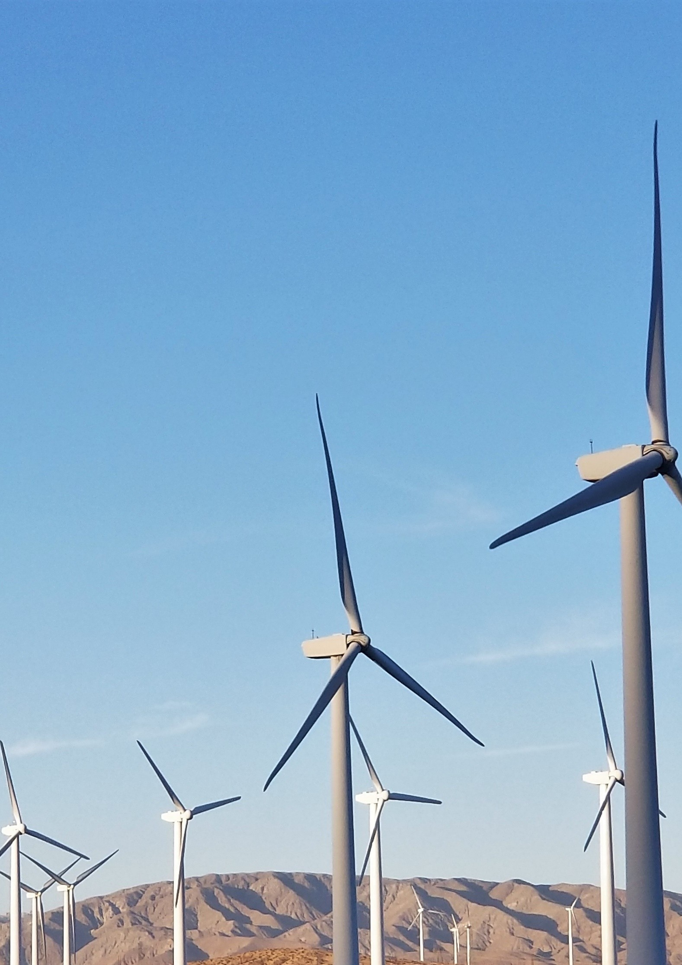

**Application Form to Wheel Electricity in the Municipal Electricity Reticulation Network**

***

**Municipality Logo**

**Application Form for Third Party Electricity Wheeling in the Municipal Electricity Reticulation Network**

XX Local Municipality

|  |
| --- |
| Version: 21 July 2023 |

|  |  |  |  |  |  |  |  |  |
| --- | --- | --- | --- | --- | --- | --- | --- | --- |
| **Y** | **Y** | **Y** | **Y** | **M** | **M** | **D** |  | **D** |

**Date of application:**

# Who needs to fill in this application form?

This form should be filled in by the IPP, trader (if applicable) and off taker/customer of the municipality whose name the property is registered under and whose name the electricity account is in (i.e., Municipal Account Holder), who intends on engaging in a third-party wheeling transaction.

This form must then be submitted by the off taker/customer.

Electricity wheeling refers to the delivery of electrical energy over the Transmission and Distribution Network from generators to customers. Third-party wheeling is a financial transaction where through a bi-lateral/multi-lateral transaction, a generator sells their generated electrical energy to another party, using the existing distribution or transmission infrastructure of a Licensee.

When third-party wheeling takes place to a municipal customer (referred to as the off taker in this instance), a Power Purchase Agreement (PPA) is signed between the generator or trader and the customer.

# Application Conditions

* Complete this application form.
* Email completed form and additional required documents (see section 7: Documents to attach) to your relevant municipal office (email@xxxx)
* The municipality will either approve or reject your application providing reasons.
* If approved, you will need to sign an amended supply agreement and Use of Systems Agreement (UoSA) with the municipality.
* The municipality may perform a site investigation of the customer’s municipality metering installation.
* If the municipal meter is not a 4-quadrant smart meter, the municipality will install a 4 quadrant smart municipal meter at the customer’s cost.
* Third-party wheeling can then commence as per the start date specified in the Power Purchase Agreement (PPA).

# Municipal Customer Information

|  |  |  |  |
| --- | --- | --- | --- |
| **Contact person information** | | | |
| Contact Person Name and Surname: |  | | |
| Contact Person Phone Numbers: (in international format) | Tel:  +27 11 123 4567 | | Cell:  +27 83 123 4567 |
| Contact Person Email Address: |  | | |
| **Company information** | | | |
| Company Name: | Company that owns the property and whose name the account is in | | |
| Company Registration number: |  | | |
| Company Physical Address: |  | | |
| Company Postal Address: |  | | |
| **Site information** | | | |
| Name of site to wheel to: |  | | |
| Address of site to wheel to: |  | | |
| Municipal Account Number: |  | | |
| Existing Tariff: | e.g. Tariff E | | |
| Supply voltage (kV): | e.g. 11kV | | |
| Notified Maximum Demand (MVA) of Customer: |  | | |
| Average Annual Electricity Consumption (MWh) of Customer: |  | | |
| Estimated Future Consumption (MWh) of Customer for next year: |  | | |
| Site / Property Erf / farm / portion No (as per municipal account): |  | | |
| Site GPS coordinates | Latitude (dd mm ss) | |  |  |  |  |  |  |  |  |  |  |  | | --- | --- | --- | --- | --- | --- | --- | --- | --- | --- | --- | | S |  |  | ° |  |  | ‘ |  |  |  | `´ | | |
|  | Longitude (dd mm ss) | |  |  |  |  |  |  |  |  |  |  |  | | --- | --- | --- | --- | --- | --- | --- | --- | --- | --- | --- | | E |  |  | ° |  |  | ‘ |  |  |  | `´ | | |

# Generator Information

If you intend wheeling from more than 1 site (i.e. an aggregation of multiple sites), please attach a schedule to this application for of each property with their address, municipal account number, tariff, supply voltage (kV) etc [i.e. all information requested about the site as per the below].

If you are purchasing electricity from a pool of power from a Trader and do not know the source of the generation, please tick this box and move on to section 5.

|  |  |  |  |
| --- | --- | --- | --- |
| **Contact person information** | | | |
| Generator Contact Person Name and Surname: |  | | |
| Generator Contact Person Phone Numbers: (in international format) | Tel:  +27 11 123 4567 | | Cell:  +27 83 123 4567 |
| Generator Contact Person Email Address: |  | | |
| **Company information** | | | |
| Company Name: | Company that owns the generating plant | | |
| Company Registration Number: |  | | |
| Company Physical Address: |  | | |
| Company Postal Address: |  | | |
| **Site information** | | | |
| Name of the Generating site: |  | | |
| Address of the Generating site: |  | | |
| Source of Electricity Generation: | Solar PV, Wind, Biogas, Biofuel, etc | | |
| Is the Generator point of connection with a municipality or Eskom? (Tick appropriate box) | □Eskom point  □Municipal point  If municipal, which municipality?____________________________________ | | |
| Eskom or Municipal Account Number: |  | | |
| Existing Tariff: | e.g. Megaflex Gen | | |
| Supply voltage (kV): | e.g. 66 kV | | |
| Maximum Export Capacity of generating site (MW): |  | | |
| Average Annual Electricity Generated (MWh): |  | | |
| Site / Property Erf / farm / portion No(as per municipal account): |  | | |
| Site GPS coordinates | Latitude (dd mm ss) | |  |  |  |  |  |  |  |  |  |  |  | | --- | --- | --- | --- | --- | --- | --- | --- | --- | --- | --- | | S |  |  | ° |  |  | ‘ |  |  |  | `´ | | |
|  | Longitude (dd mm ss) | |  |  |  |  |  |  |  |  |  |  |  | | --- | --- | --- | --- | --- | --- | --- | --- | --- | --- | --- | | E |  |  | ° |  |  | ‘ |  |  |  | `´ | | |

# Energy Trader Information (if applicable)

Please complete this section if an energy trader is involved in the wheeling transaction.

|  |  |  |
| --- | --- | --- |
| **Contact person information** | | |
| Trader Contact Person Name and Surname: |  | |
| Trader Contact Person Phone Numbers: (in international format) | Tel:  +27 11 123 4567 | Cell:  +27 83 123 4567 |
| Trader Contact Person Email Address: |  | |
| **Company information** | | |
| Company Name: |  | |
| Company Registration number: |  | |
| Company Physical Address: |  | |
| Company Postal Address: |  | |
| NERSA trading licence number: |  | |

# Wheeling Transaction Details

Please attach signed/draft PPA and/or letter of intent (see section 7: Documents to attach)

|  |  |  |
| --- | --- | --- |
| Wheeling scenario  (Tick relevant option): | Eskom-connected generator wheeling to a Municipal Customer. In this scenario the Generator is located outside the Municipal boundaries whilst the Customer is located within the Municipal boundaries. |  |
| Municipal-connected generator wheeling to a Municipal Customer. In this scenario both the Generator and the Customer are located withing the Municipal boundaries. |  |
| Municipal-connected generator wheeling to Eskom-connected Customer or a Municipal Customer in another municipality. In this scenario the Generator is located inside the Municipal boundaries whilst the Customer is located outside the Municipal boundaries. |  |
| Municipal Customer purchasing electricity from a Trader. The Trader may be sourcing power from one or more generators that can be Eskom/municipality connected, and anywhere in the country/region. |  |
| **Other:** |  |
| Electricity wheeling project Description: | Provide details of the wheeling project to give assessors a picture of the generator, the customer, and electricity wheeling transaction. E.g. A ground mounted solar PV plant of 15MW located in xx is constructed and the generated electricity is wheeled to an industrial facility located in Municipality. | |
| Estimated Wheeling Start Date: |  | |
| Estimated Wheeling End Date: |  | |
| Contract Capacity: Agreed quantum(MWh) or percentage of total generation (%) to be wheeled to customer: |  | |

# Documents to attach

Please attached the below documents to this application form:

|  |  |
| --- | --- |
| **Document** | **✓** |
| Draft / Signed Power Purchase Agreement (between customer and generator or trader) |  |
| Letter of Intent (between customer and generator or trader) |  |
| ID of company owner or director (i.e the off taker) |  |
| Company Letter of Authority and Board Resolution for signatory |  |
| ID of signatory if not the company owner or director |  |
| Copy of Energy Trader’s NERSA trading licence (if applicable) |  |
| List of multiple customer sites where electricity will be wheeled to, with addresses, tariffs, supply voltage etc. (if applicable) |  |
| List of multiple generation sites where electricity will be wheeled from, with addresses, tariffs, supply voltage etc. (if applicable) |  |
| Connection and UoS agreement with Eskom (when applicable) |  |

# Declaration

I request the Municipality to proceed with a preliminary review of this application to wheel electricity in the electricity reticulation network of the Municipality and I agree to pay the cost associated with completing this review, including costs to cover any studies necessary for such assessment.

I further consent to the Municipality providing this information to the National Electricity Regulator of SA (NERSA) and other Distributors as required.

I declare that the generator and other role-players comply with the regulatory requirements and standards applicable, and I acknowledge the conditions and processes outlines in the *HOW TO GUIDE FOR MUNICIPALITIES TO ESTABLISH AND RUN THE THIRD-PARTY WHEELING PROCESS* document.

**Municipal Account Holder/Representative signature:**

|  |
| --- |
| _______________________________ ____________________ _______________________  Name Date Signature |

**Generator / Trader signature:**

|  |
| --- |
| _______________________________ ____________________ _______________________  Name Date Signature |

**Municipality signature:**

|  |
| --- |
| _______________________________ ____________________ _______________________  Name Date Signature |