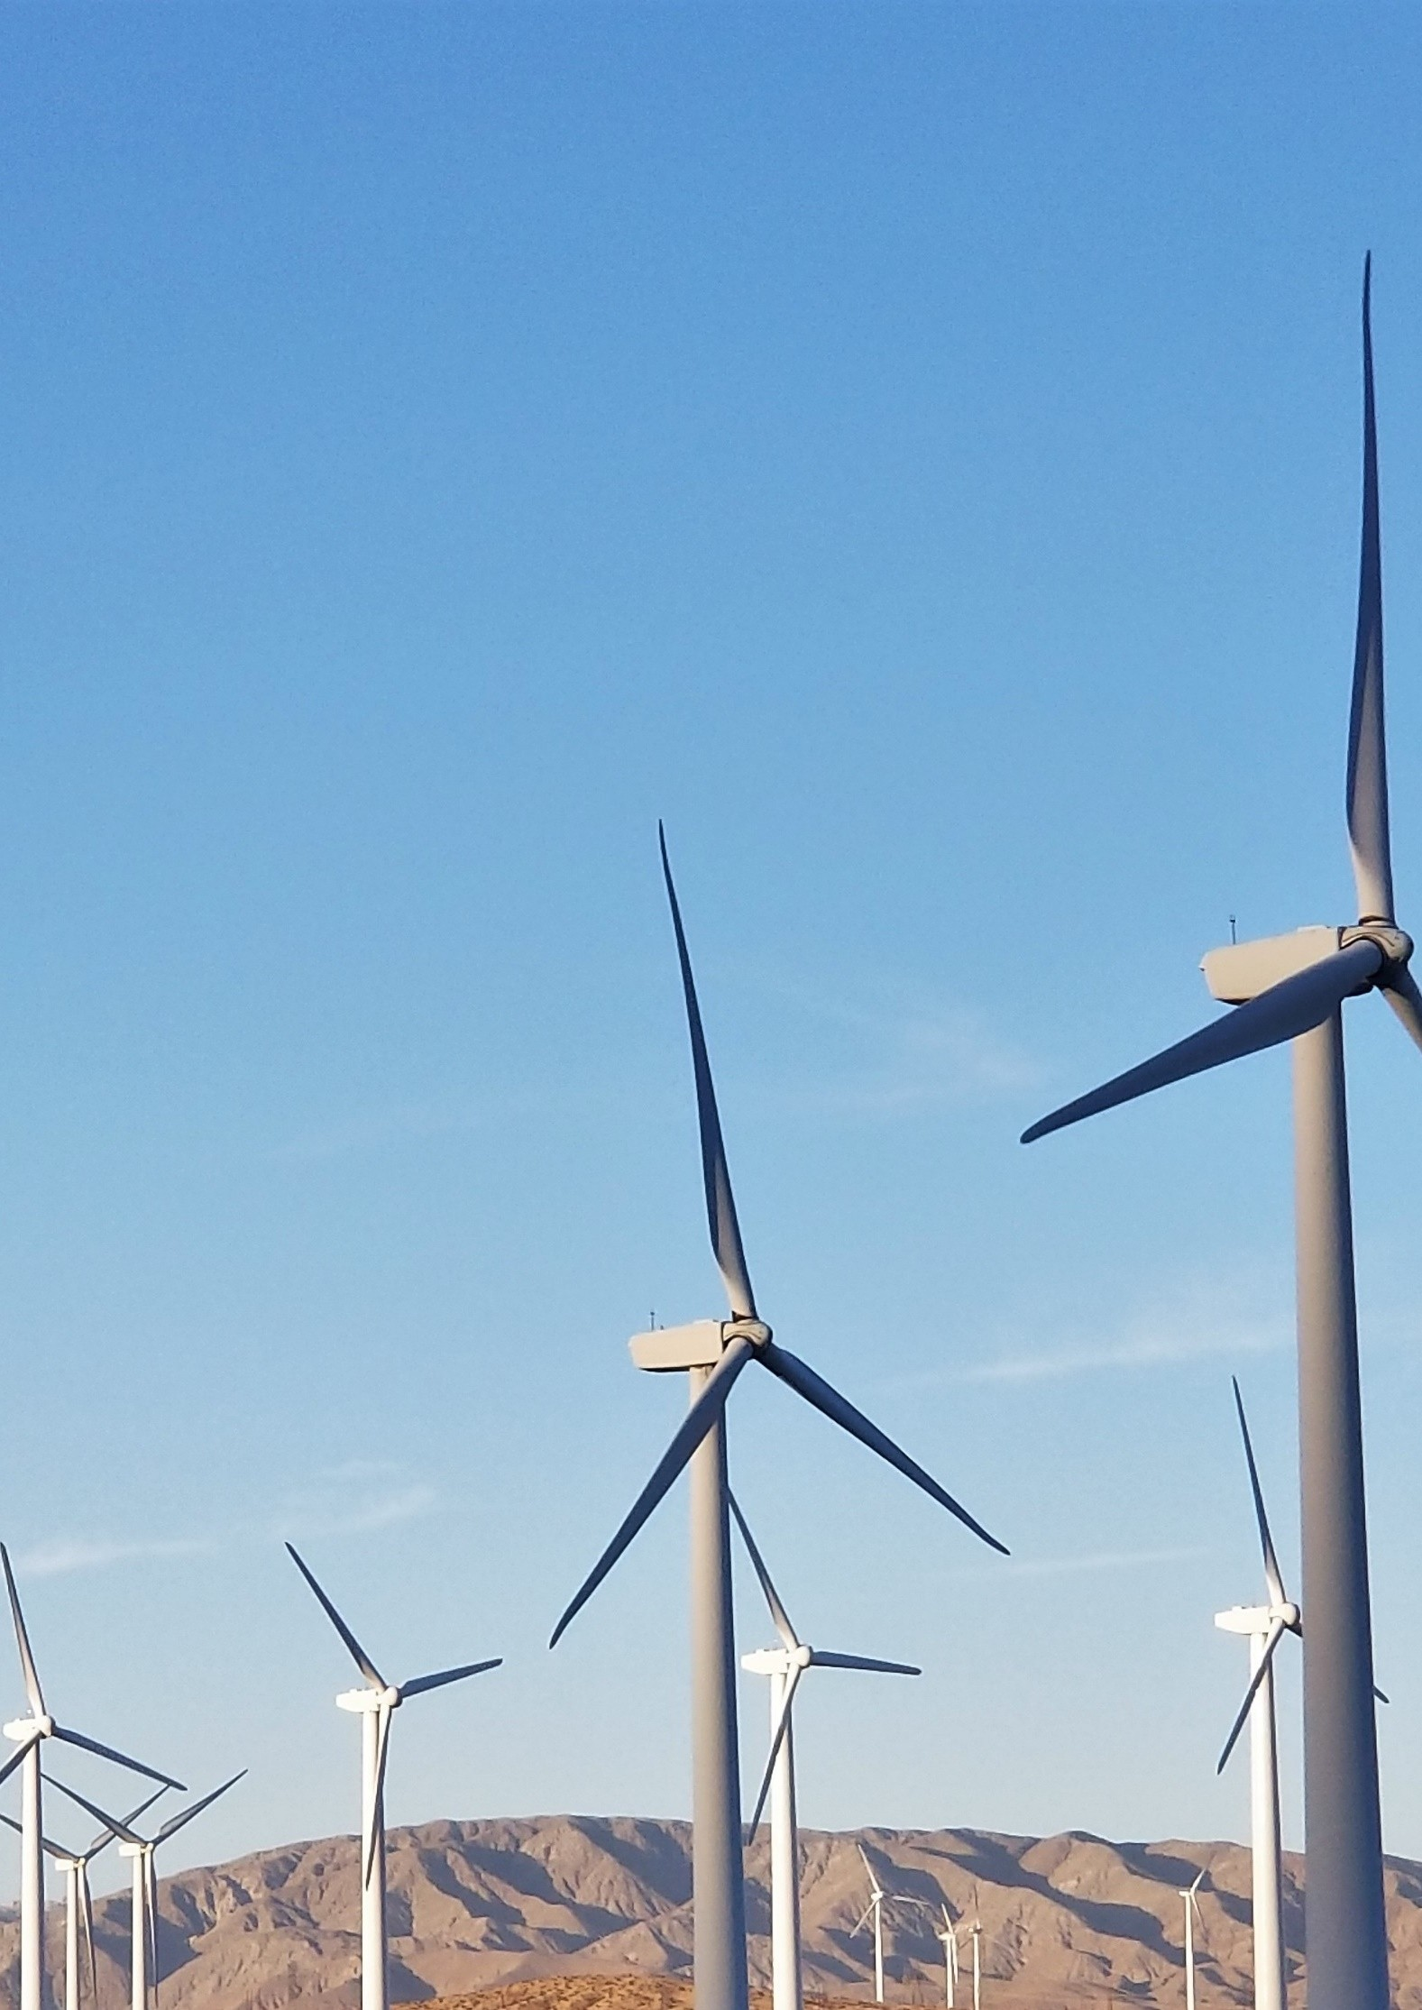

**GUIDE FOR MUNICIPALITIES ON HOW TO ESTABLISH AND RUN THE THIRD-PARTY WHEELING PROCESS**

**TO**

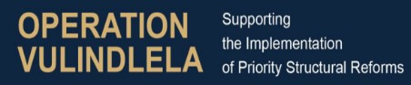



# Executive Summary

This comprehensive Municipal Wheeling Guidelines document serves as a vital resource for municipalities embarking on third-party energy wheeling within their distribution grids. It systematically addresses legal, regulatory, technical, and operational aspects of energy wheeling. This executive summary provides an overview of the guide's structured content and the significance of each section.

Energy wheeling is the transmission of electrical energy through existing distribution or transmission infrastructure, enabling generators to sell their energy to other parties. With municipalities experiencing a surge in requests for third-party wheeling, the need for clear guidelines and processes is paramount. Municipalities stand to reap numerous benefits from third-party wheeling initiatives, including revenue generation, economic growth, energy security, and environmental sustainability. By promoting private investments, green initiatives, and technological advancements, municipalities can bolster their communities and energy management capabilities.

To establish and operate third-party energy wheeling, municipalities should follow an 11-step process. This begins with conducting internal workshops involving key stakeholders, such as legal, finance, and electricity departments, to gain staff buy-in. Step 2 entails developing wheeling tariffs, service guidelines, and processes, including cost of supply studies, qualification requirements, and legal frameworks. Council approval, public participation (if needed), and submission of wheeling tariffs to the National Energy Regulator of South Africa (NERSA) follow in steps 3 to 5. Step 6 involves tariff approval as part of the budget process, ensuring alignment with the municipality's financial plan. The next steps, 7 and 8, require finalizing the wheeling policy, obtaining approvals, and customizing wheeling agreements. Step 9 focuses on preparing or upgrading the billing system, while step 10 involves testing the project if required. Finally, step 11 entails opening the third-party wheeling market, officially launching the service, ensuring accessibility, and maintaining ongoing monitoring and improvement mechanisms. These steps collectively guide municipalities in establishing and operating successful third-party energy wheeling systems, aligning with national regulations and optimizing benefits for their communities and long-term energy strategies.

This document then serves as a comprehensive resource to effectively develop the wheeling service guidelines and processes, as outlined in step 2Step 2 in. The guide is thoughtfully structured into several sections, each meticulously designed to address a specific aspect of third-party energy wheeling. It begins with an overview of the document, providing a clear understanding of its purpose and usage. The subsequent sections offer a wealth of information, from acronyms and definitions that ensure clarity to a detailed exploration of the legal and regulatory framework that underpins wheeling operations. As the guide unfolds, it delves into the roles and responsibilities of key stakeholders, emphasizing the collaborative nature of wheeling services. General guidelines and conditions are outlined to establish a strong foundation for contractual arrangements, a critical component in ensuring the smooth operation of third-party wheeling. Metering and data management, often considered the backbone of wheeling services, are comprehensively discussed, alongside tariff structures, billing procedures, and various scenarios for contracting, metering, and billing. Qualifying criteria and application processes are detailed to ensure transparent access to wheeling services. Throughout the guide, vital topics such as payments, energy balancing, and dispute resolution are meticulously examined, contributing to the robustness of the wheeling framework. Tools, references, and further information are provided to empower municipalities with additional resources. To facilitate technical implementation, annexures offering technical standards and illustrative examples of qualifying criteria are included. This structured approach equips municipalities with the knowledge and guidance necessary to develop a tailored wheeling framework, aligning their operations with national policies and regulations, while harnessing the manifold benefits of third-party energy wheeling for their communities and long-term energy management strategies.

This comprehensive guide has been collaboratively developed and contributed to by several esteemed organizations and companies. By effectively utilizing this guide, municipalities can establish a robust wheeling framework, align with national policies and regulations, and harness the benefits of third-party energy wheeling for their communities and long-term energy management strategies

# Quick Reference Guide

|  |  |
| --- | --- |
| **Purpose of the document** | This guideline describes for municipalities on how to establish and run the third-party wheeling process to/from/within a Municipality’s distribution grid. |
| **Defining third party wheeling** | Electricity wheeling refers to the delivery of electrical energy over the electricity network from generators to customers. Third-party wheeling is a financial transaction where, through a bi-lateral or multi-lateral transaction, a generator sells their generated electrical energy to another party, using the existing distribution or transmission infrastructure of a Licensee. |
| **The need for this document** | Municipalities are receiving an increasing number of requests to wheel across their distribution grid, where either, or both, the generation facility and the customer premises are located within a Municipality jurisdiction and connected to their grid. It is important that municipalities develop wheeling guidelines and processes for the following reasons:   * Revenue Generation: Third-party wheeling generates new income through charges, fees, and connection costs, providing funds for local infrastructure and development projects. * Economic Growth: Encouraging private investments in generation fosters job creation and economic activity within the municipality. * Energy Security: Diverse energy sources from private generation projects reduce dependency on a single energy supply, enhancing resilience against disruptions. * Green Initiatives: Facilitating wheeling aligns with sustainability goals, promoting clean energy projects and lowering carbon emissions. * Technological Advancement: Partnering with private generators introduces advanced technologies and innovation, positioning the municipality as a tech-savvy hub. * Collaboration: Partnerships with energy generators foster knowledge exchange and a supportive energy ecosystem. * Infrastructure Development: Private investments can lead to shared infrastructure improvements, benefiting both the municipality and energy projects. * Community Impact: Revenue from wheeling supports local services like education, healthcare, and public infrastructure. * Regulatory Compliance: Clear guidelines showcase commitment to regulations, enhancing the municipality's reputation and attracting further investment. * Strategic Leadership: Proactive wheeling guidelines position the municipality as an energy management leader, attracting stakeholders and investors. * Load Shedding Mitigation: Wheeling supports private sector investment in generation and storage, contributing to reducing or eliminating load shedding incidents in the long term. * Decarbonization and Sustainability: Wheeling enables customers to access clean energy, aiding in their efforts to reduce carbon footprints and meet sustainability targets. * Cost Efficiency: Customers can potentially secure cost-effective electricity through wheeling, leading to reduced electricity expenses. * Price Certainty: Wheeling facilitates long-term power purchase agreements, offering customers stable electricity costs over time. * Geographical Flexibility: Customers gain the ability to source energy from generation facilities not physically connected to their premises, enhancing energy procurement options.   By embracing these benefits, municipalities can create a comprehensive framework for wheeling that not only supports customer needs but also aligns with local development strategies and energy sector advancement. Further, distribution licensees are obligated to provide non-discriminatory access to their electricity grids and must therefore facilitate the wheeling of electricity across distribution grids. |
| **Scope** | This document covers:   * Operational procedures – how to establish and run the process * The legal and regulatory framework for wheeling * Wheeling scenarios * A technical overview of wheeling in the Municipality * The Municipality’s Wheeling Requirements outlining how wheeling will be facilitated |
| **Who this document is for** | This document will assist The Municipality involved in electricity distribution and all relevant stakeholders involved in the conceptualization, development, installation, management and ownership of the third-party wheeling process and systems. Other relevant stakeholders may include:   * Wheeling project developers * Large power users considering wheeling * Energy consultants commissioned to design wheeling systems * Electricity traders and wholesale buyers |
| **Steps for a municipality to take to establish & operate third-party energy wheeling** | **Step 1: Conduct internal workshop/s and get staff buy in:**  This involves bringing together key stakeholders to brainstorm and plan for the establishment of a wheeling service. The workshop may include representatives from the legal, finance, and electricity departments, as well as other relevant departments or stakeholders. The key stakeholders may include:   * Legal Department: This department is responsible for ensuring that all legal requirements are met. They should provide guidance on compliance with relevant legislation and regulations pertaining to energy wheeling. They will be involved in drafting contracts and agreements, ensuring that all parties involved in the wheeling service are protected legally, and in addressing any legal issues that may arise during the process. * Finance Department: The finance department plays a crucial role in the financial planning and budgeting aspects of establishing and operating a wheeling service. They will work on determining the appropriate tariffs and compensation agreements for wheeling services. They will assess the financial feasibility of the project, including costs associated with infrastructure, maintenance, and administration, and propose funding mechanisms to support the initiative. * Electricity Department: The electricity department is responsible for the technical aspects of the wheeling service. They will oversee the interconnection process, ensuring that the necessary infrastructure and equipment are in place for the transmission and distribution of electricity. They will also ensure compliance with electrical safety standards and address quality of supply requirements to ensure reliable and efficient energy wheeling. * Metering Division / Section: This division or section assumes a pivotal role in facilitating energy accounting and seamless transactions within the wheeling framework. Its responsibilities encompass the meticulous implementation and management of Advanced Metering Infrastructure (AMI), specifically the deployment of Advanced Meter Reading (AMR) 4 Quadrant meters. These sophisticated meters are instrumental in capturing bidirectional energy flows, recording both import and export of electricity accurately. * IT Department: The IT department plays a critical role in enabling the technological backbone of energy wheeling. They develop and manage the billing systems and digital infrastructure required for real-time data exchange, communication between energy generators and consumers, and the secure transfer of energy consumption and billing information. Their responsibilities include maintaining data security, system reliability, and facilitating seamless data exchange among all involved parties. * Economic Development Department: The economic development department plays a crucial role in assessing the potential benefits of energy wheeling for the municipality. They will analyse the economic impact, job creation potential, and overall development prospects associated with the establishment of a wheeling service. They will work on developing strategies to attract and retain businesses, promote investment, and foster sustainable economic growth through the availability of reliable and affordable electricity.   **Step 2: Develop the wheeling tariffs, service guidelines and processes:**  This step involves defining the guidelines for the wheeling service, including the scope of the service, the requirements for participation, the procedures for application and approval, and the technical requirements. The following processes need to be developed:   * Cost of supply study and unbundling tariff: The Municipality play a critical role in conducting cost of supply studies and ensuring their accuracy and relevance as well as ensure cost reflective and functional tariffs. the Cost of Supply Study and Unbundling Tariff process is essential because it ensures accurate, fair, and transparent pricing for using the distribution grid. This pricing not only supports the financial viability of the municipality but also encourages investment, promotes transparency, and ensures the long-term sustainability of the energy ecosystem. For support, please see link below for key actions that The Municipality need to undertake in this regard:   + [Cost of Supply Studies - Embedded Generation Resource Portal (sseg.org.za)](https://www.sseg.org.za/cos/). Resources to support municipalities improve their electricity cost of supply practices.   + [1-31741 19-12 Min (energy.gov.za)](https://www.energy.gov.za/files/policies/Electricity%20Pricing%20Policy%2019Dec2008.pdf). The EPP 2008 (DMRE) is a document that outlines the policy framework for electricity pricing in South Africa. It was published by the Department of Minerals and Energy in the Government Gazette on 19 December 2008.   + [Published-Consultation-Paper-COS-Framework-Final-1.pdf (nersa.org.za)](https://www.nersa.org.za/wp-content/uploads/2021/01/Published-Consultation-Paper-COS-Framework-Final-1.pdf) The cost of supply framework 2016 (NERSA) is a document that provides guidelines for licensed electricity distributors to conduct cost of supply studies. It was issued by the National Energy Regulator of South Africa (NERSA) in March 2015. * Qualification requirements: This sets out what are the specific qualifying criteria, guidelines and conditions to wheel energy within the municipal grid. * Application procedure: This involves defining the process for submitting an application for third-party access/open access transmission, including the required documentation and timelines. * Legal and contractual framework: This involves defining the legal and contractual framework for the wheeling service, including contracts and agreements between the generator, municipality, customer, and potentially a trader. Note that the municipality will also have to sign an Amended Energy Supply Agreement with Eskom for wheeling. * Billing and invoicing procedure: This involves defining the process for billing and invoicing for the wheeling service, including the establishment of tariffs, payment terms, and billing cycles. * Tariff documentation: This involves preparing the tariff documentation, including the tariff structure, rates, and any special conditions or discounts. * Data exchange**:** This involves defining the procedures for data exchange between the generator, municipality, customer, and potentially a trader, including the format and frequency of data sharing.   **Step 3: Council to approve wheeling as a service (if applicable):**   * This critical step involves obtaining official approval from the municipality or other relevant authority to establish the wheeling service. The process for council approval must be conducted in accordance with the Municipal Finance Management Act (MFMA) and the Municipal Systems Act. * During this stage, the municipality's officials must follow the necessary procedures to have the wheeling policy and by-laws approved. The wheeling policy will include qualifying criteria and guidelines for the service.   **Step 4: Public participation (if needed):**   * This step involves engaging with the public to obtain feedback and input on the proposed wheeling service, particularly if the service will have a significant impact on the community. * The municipality reviews the public feedback, adjusts the policy if necessary, and incorporates relevant suggestions from stakeholders.   **Step 5: Submit wheeling tariff to NERSA:**  This step involves submitting the wheeling tariff to the National Energy Regulator of South Africa (NERSA) for review and approval, if required. As per approved national wheeling framework when applicable.  **Step 6: Tariff approval, as part of budget process:**  This involves obtaining approval for the wheeling tariff as part of the budget process and ensuring that the tariff is consistent with the overall financial plan for the municipality or other relevant authority.  **Step 7: Approved wheeling policy and wheeling tariff:**   * This involves finalizing the overall wheeling policy, including any additional requirements or guidelines as well as obtaining final approval for the wheeling policy and tariff from the municipality or other relevant authority. * Once the wheeling policy and tariff are approved by the relevant authorities, they will be gazetted by the government, providing a framework for implementing the wheeling service within the municipality's jurisdiction   **Step 8: Customize wheeling agreements**   * Begin by reviewing the available templates and user guides pertaining to wheeling agreements. * Adapt these templates to make them applicable to the specific needs and context of the municipality. * Share the customized agreement with key departments (like the legal department) and stakeholders for feedback. * Adjust based on the feedback received and obtain a legal review to ensure the agreement complies with all regulations and protects the interests of the municipality. * After the legal sign-off, finalize the wheeling agreement for implementation.   **Step 9: Prepare / Upgrade billing system**   * Assess the capabilities of the existing billing and metering system. * Based on the assessment, identify the need for a smart metering system solution integrated with a meter data management system. * Draft a comprehensive list of requirements for the new billing and metering system, considering the complexities introduced by wheeling services. * Initiate a transparent procurement process to select the right vendor/solution for the billing and smart metering system. * Once procured, integrate the smart metering system with the billing system and conduct test runs to check for glitches. * Train the relevant personnel to understand and operate the new system. * Establish a mechanism for users and staff to report any issues or provide feedback on the new system.   **Step 10: Testing project, if required**   * Identify a small group of customers to trial the wheeling service. * Set a specific timeframe for the pilot, e.g., 6 months. * Continuously monitor the process, noting successes and areas of concern. * At the end of the pilot, gather feedback from participants and make necessary adjustments based on lessons learned during the pilot. * The Municipality is note that this step can be   **Step 11: Open third-party wheeling market**   * Announce the official launch of the wheeling service to the public. * Make the application process clear and accessible to all potential users. * Set up a helpline or support centre to assist users with their queries or concerns. * Consistently monitor the system, addressing any issues or concerns that arise. * Periodically review the service, making necessary adjustments and improvements as needed. |
| **How this document must be used** | This document serves as a comprehensive resource to effectively develop the wheeling service guidelines and processes, as outlined in step 2. It provides the necessary content and materials to assist the Municipality in establishing a solid foundation for their wheeling framework. The information presented in this guide offers a base template that can be modified to suit the specific needs and requirements of the Municipality.  The guide is divided into various sections, each addressing key aspects of the wheeling process and providing valuable insights and recommendations. Within each section, you will find detailed explanations and instructions to support the Municipality in developing their own customized wheeling framework.  At the start of the section there is an‘**’🔍 Explanatory notes’’** sectionwhich refers to additional information, explanations, or clarifications provided in written documents or guidelines to enhance understanding, provide context, or elaborate on specific points.  The ‘**’💡Illustrative example’’** section then helps the Municipality or reader to better understand the concept by presenting a real or hypothetical situation that showcases how the concept is applied or functions in practice. These examples often include specific details, descriptions, or visuals to enhance comprehension and aid in the retention of information. The Municipality must use the information in this section and make relevant to their specific Municipality by adding and updating accordingly.  By utilizing this comprehensive guide, the Municipality can leverage the expertise and insights provided to establish a robust wheeling framework. The combination of explanatory notes and illustrative examples empowers the Municipality to customize their approach while ensuring compliance with national policies and regulations.  After the Municipality has created their guide, they can formulate a Municipality-specific policy for public use. This policy will usually encompass broad directives, terms, qualifying criteria, and the application procedure. In essence, the Municipality should:   * Construct their internal Third-Party Municipal Wheeling Guideline as an internal service blueprint, delineating processes and guidelines. * Subsequently, craft an external public Third-Party Municipal Wheeling policy, drawing from the guideline's contents and incorporating pertinent elements. This policy will be accessible to the public, offering a clear outline of procedures and regulations.   The Tools, References and Further Information in section 18 of this document contains links to resources that may be useful for prospective parties interested in wheeling electricity. |
| **Simplified vs. Comprehensive Municipal Wheeling Guideline** | In our pursuit of supporting municipalities in the successful implementation of third-party wheeling, there are two distinct guideline options: the Simplified Municipal Wheeling Guideline and the Comprehensive Municipal Wheeling Guideline. This diversity allows you to select the approach that aligns most effectively with your municipality's readiness, resources, and objectives.  **Option 1: Simplified Municipal Wheeling Guideline**  The Simplified Guideline offers a concise overview of the fundamental aspects of third-party wheeling. It is an ideal starting point for municipalities seeking a quick understanding of the essentials. This guide provides:   * A brief yet insightful introduction to third-party wheeling. * An overview of the legal and regulatory considerations. * Basic insight into roles and responsibilities of key stakeholders. * A snapshot of the application process and its main components.   This guide is particularly suited for municipalities that are in the early stages of considering third-party wheeling or have limited resources to allocate for a comprehensive exploration.  Link - [Template Municipal Wheeling Guideline - Embedded Generation Resource Portal (sseg.org.za)](https://www.sseg.org.za/template-municipal-wheeling-guideline/)  **Option 2: Comprehensive Municipal Wheeling Guideline**  The Comprehensive Guideline, which you are reading right now, is an extensive resource that delves deeply into every facet of third-party wheeling. It is tailored for municipalities that are committed to harnessing the full potential of this energy management strategy. This guide includes:   * A comprehensive exploration of the legal and regulatory landscape. * In-depth understanding of roles and responsibilities across various departments. * Detailed insights into contractual arrangements and agreements. * Technical implementation guidelines, metering best practices, and data management. * Crafting effective tariff structures and understanding billing intricacies.   The Comprehensive Guideline is the perfect fit for municipalities that are well-resourced and dedicated to implementing third-party wheeling with meticulous precision.  **Choosing the Right Guide: A Simple Assessment**  Selecting the most suitable guide is essential for ensuring a successful journey in third-party wheeling. Consider the following factors:   * Where Are You on Your Journey?   + If you are at the exploratory stage, the Simplified Guide provides a solid foundation.   + If you are committed to implementation, the Comprehensive Guide is your comprehensive companion. * Resource Availability:   + If resources are limited, the Simplified Guide offers a streamlined introduction.   + If resources are abundant, the Comprehensive Guide equips you for in-depth execution. * Plan Maturity:   + If your plan is in its infancy, the Simplified Guide helps shape initial steps.   + If you have a mature strategy, the Comprehensive Guide ensures meticulous execution.   Both guides reflect a commitment to success. Whichever option you choose, our support remains steadfast. Feel free to review the attached documents to make an informed decision that resonates with your municipality's objectives. |
| **Who has developed and contributed to this Template** | The initial base third-party municipal wheeling guideline document and updated operational third-party municipal wheeling guideline document was developed and contributed to by the following organizations and companies.   * GIZ * EY * Sustainable Energy Africa * Energy Council of South Africa * Greencape * Western Cape Government * City of Ekurhuleni * Swartland Municipality * SALGA * Enpower * Solar Africa * Meerkat Energy * Meter Academy & Services   For any clarification required on any aspects please contact   * Rashid Khan CA (SA) on [rashid.khan@za.ey.com](mailto:rashid.khan@za.ey.com) or 0836110925 * Gerhard Mynhardt on [gerhardus.jozoua.mynhardt@za.ey.com](mailto:gerhardus.jozoua.mynhardt@za.ey.com) or 834129895 |

# Infographic on steps

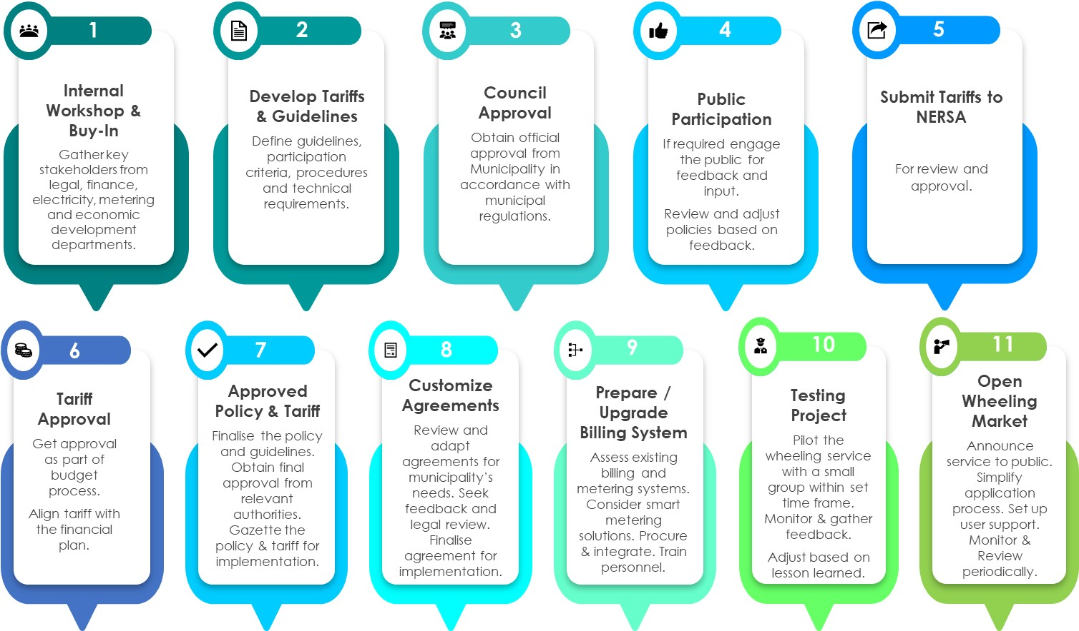Steps for a municipality to take to establish & operate third-party energy wheeling. This embedded document provides all the infographic and scenario images in editable format. (double click the icon)



**Municipality Logo**

**Third Party Municipal Wheeling illustrative Guidelines**

XX Local Municipality

|  |
| --- |
| Guideline for allowing third-party access to XX Local Municipality’s electrical network  Version 1: September 2023 |

# Contents

5. List of Acronyms 3

6. List of Definitions 4

7. Introduction 6

8. Legal & Regulatory Framework 9

9. Roles and Responsibilities of Stakeholders 10

10. General Guidelines and Conditions 12

11. Contractual Arrangements 14

12. Metering and Data 18

13. Tariffs, Charges and Billing 24

14. Scenarios for Contracting, Metering & Billing 29

15. Qualifying Criteria 35

16. Application Process 39

17. Generator Connection Process 42

18. Payments Due 42

19. Energy Supply and Demand Balancing 44

20. Dispute Resolution Process 45

21. Tools, References and Further Information 46

22. Proposed IT Systems to Implement 47

23. Annexure A - Technical Standards and Legislation 53

24. Annexure B - Qualifying Criteria Illustrative Examples 54

25. Annexure C - Smart Metering Solution Components 58

# List of Acronyms

🔍 ***Explanatory notes:***

*Including a list of acronyms in a document enhances clarity and comprehension. It ensures that readers understand the meanings behind abbreviations, promotes consistency in language usage, and improves accessibility for individuals unfamiliar with specific terminology. By expanding acronyms in a dedicated list, the document remains concise while allowing readers to easily reference and grasp the full terms associated with each acronym. Within the document, the first time the term is used it should be written out in full with the acronym in brackets, and thereafter you may use the acronym only. Overall, a list of acronyms enhances communication by facilitating understanding and avoiding confusion. The municipality official can add to the below list based on updates made to the document. The list below is only a sample list and may need to be updated by the Municipality to suite own needs.*

**💡Illustrative example**

|  |  |
| --- | --- |
| **ADMS**  **AMI**  **DERMS**  **DFFE**  **DMRE**  **DSO**  **EA**  **EG**  **ERA**  **EPP**  **JETP**  **IPP**  **kW**  **kWh**  **MDMS**  **MFMA**  **MW**  **MWh**  **NRS**  **NSP**  **NERSA**  **PPA**  **REC**  **REIPPP**  **SANS**  **SEA**  **SSEG**  **TSO**  **ToU**  **UOS**  **WEPS**  **xxx** | Advanced Distribution Management System  Advanced Metering Infrastructure  Distributed Energy Resource Management System  Department of Fisheries, Forestry and Environment  Department of Mineral Resources and Energy  Distribution System Operators  Environmental Authorisation  Embedded Generation  Electricity Regulation Act  Electricity Pricing Policy  Just Energy Transition Partnership  Independent Power Producer  Kilowatt  Kilowatt Hours  Meter Data Management System  Municipal Finance Management Act  Megawatt  Megawatt Hours  National Regulatory Services  Network service providers  National Energy Regulator of South Africa  Power Purchase Agreement  Renewable energy certificates  Renewable energy Independent Power Producer Programme  South African National Standard  Sustainable Energy Africa  Small Scale Embedded Generator  Transmission Systems Operator  Time of Use  Use of System  Wholesale Energy Pricing Structure  xxxx |

# List of Definitions

🔍 ***Explanatory notes:***

*Including a list of definitions in a document serves important purposes:*

* *Clarification: Definitions ensure a shared understanding of terms, eliminating confusion.*
* *Standardization: Consistent language usage is promoted throughout the document.*
* *Accessibility: Readers can quickly reference and grasp the meaning of key terms.*
* *Contextualization: Definitions provide background information for better comprehension.*
* *Precision and accuracy: Clear definitions prevent misunderstandings.*
* *Legal and technical requirements: Some industries may mandate definitions for compliance.*

*A list of definitions enhances a document's readability, comprehension, and communication among readers and stakeholders.*

**💡Illustrative example**

**Active energy charges -** The charges associated with the consumption of electricity

**Avoided Cost -** The Avoided Cost of energy means the marginal costs a utility would avoid in any given hour if a distributed electrical energy resource provided electricity instead of the utility. For Distributors at the retail level, this would be their energy purchase costs plus potentially technical losses in high load areas.

**Buyer -** The Buyer of the Wheeled Energy which can be a Distributor, Trader or a customer.

**Carbon emissions:** The release of carbon dioxide and other greenhouse gases into the atmosphere, primarily from the burning of fossil fuels, which contributes to global climate change.

**Cost of supply studies:** Studies that examine the cost of producing and delivering energy to consumers, taking into account factors such as infrastructure, fuel costs, and labour.

**Customer -** Refer to the approved ERA (as amended) definition

**Distribution power system:** A power system that operates at or below 132kV.

**Distribution:** The transport of electricity through a distribution power system excluding trading, and 'distribute' and 'distributing' have corresponding meanings.

**Embedded Generator:** An electricity generating device that is connected to a customer's electrical installation beyond the point of control, such as rooftop solar panels or small wind turbines.

**Energy credit:** The monetary value of energy sold by third-party energy providers or traders and provided to customers via the licensed distributor’s grid within the municipal boundary.

**Energy Generator:** An entity that produces electricity, usually through power plants or other sources of energy, including and not limited to wind turbines, solar panels, or hydroelectric dams.

**Electricity Regulation Act (ERA):** Electricity Regulation Act 4 of 2006

**Energy Trader:** An intermediary that buys and sells electricity in the wholesale market, often acting as a bridge between generators and users.

**Eskom grid:** The transmission or distribution power system owned by Eskom.

**Flexibility:** In the context of managing energy consumption, flexibility refers to the ability to adjust energy usage in response to changing needs or conditions.

**Generator Grid Connection and Use-of-System Agreement:** A contract between the municipality or Eskom (depending on the region) and the generator that outlines the terms and conditions for physically connecting the generation facility to the electricity grid and accessing and using the grid to export electrical energy from the generation facility.

**Generator:** A entity who generates electricity.

**Grid:** An electrical power system used to transport electrical energy. Also referred to as network.

**Grid access:** The ability of a third party, such as an independent power producer (IPP) or energy trader, to access the transmission and distribution networks to sell energy capacity to buyers.

**Grid Code:** Means the distribution code, the transmission grid code, or any other code approved by the Regulator.

**Installed generation capacity:** The maximum design capacity for the amount of electrical power that can be produced by power generation facilities. This may also be termed “nameplate capacity”.

**Licensee:** The Distribution or Transmission entity licensed by NERSA to provide a network service and/or retail trading function

**Metering:** The process of measuring the amount of electricity delivered by the energy generator at an agreed delivery point

**Municipality’s grid:** The distribution power system in XX Municipality’s licensed supply area.

**Network:** The licensed national Transmission or Distribution power systems comprising powerlines and electrical energy infrastructure that allows or permits electrical energy to be generated, transported and/or delivered to customers that are connected to it.

**Network Capacity:** The maximum amount of electricity that can be transmitted over a given transmission line or network without overloading the system.

**National Energy Regulator Act NERA**: National Energy Regulator Act, 2004 (Act 40 of 2004).

**A Non-Utility Generator:** refers to an electricity generation system or device that operates independently of traditional utility companies such as Eskom or municipal providers. It is a term commonly used to describe a power generation source that is not connected to the centralized electrical grid and is typically used to generate electricity for specific purposes or locations.

**Off-taker**: A municipality electricity customer and the purchaser of third-party electrical energy, or a third-party customer located outside of the Municipal jurisdiction but where the generation facility is located with the municipalities licenced area. Also referred to as end-user.

**Power Purchase Agreements (PPA):** a legal contract between two parties, usually a power producer (such as a renewable energy developer) and a power purchaser (such as a utility, corporate entity or trader), in which the purchaser agrees to buy a specified amount of energy over a certain period of time from the producer.

**Renewable energy:** Energy that is derived from sources that are naturally replenished, such as wind, solar, hydropower.

**Self-generation:** The production of electricity by a consumer, typically for their own use, using a power generation facility located on their premises.

**Smart metering**: Is about measuring electricity usage. Instead of traditional manual meters that require someone to read them in person, smart meters, automatically record and transmit usage data without the need for physical inspections.

**Smart metering System:** The use of advanced metering technology to monitor and control energy usage

**The Constitution:** The Constitution of the Republic of South Africa, 1996.

**Third party wheeling:** Third-party wheeling is a financial transaction where through a bi-lateral transaction, a generator sells their generated electrical energy to another party, using the existing distribution or transmission infrastructure of a Licensee

**Third-party energy providers**: A generator or trader who is neither Eskom nor the Municipality.

**Trader:** A licensed entity engaged in trading or reselling.

**Trading:** The wholesale or retail buying and selling of electricity.

**Transmission:** The process of transporting electricity using high-voltage transmission power lines,

**Virtual PPA:** This refers to a contractual agreement between a consumer and a renewable energy generator, under which the consumer purchases power from the generator that is delivered to the grid in exchange for a credit on their energy bill.

**Wheeling:** The delivery of electrical energy over the Network from generators to customers.

**Wheeled Energy:** The electrical energy (kWh) produced by the generator as measured by the meter of the generator and the Licensee at one site that is sold to a Buyer at another site and this electricity is delivered from the generator to the customer through a Licensee Networks.

# Introduction

🔍 ***Explanatory notes:***

*The Introduction section of the guideline is an important part of the document as it sets the context and provides an overview of the key concepts and objectives related to third-party electricity wheeling. The following points can be considered to enhance the explanatory notes in the introduction:*

* *Regulatory Obligations: Municipalities should highlight that they are legally obligated to facilitate the wheeling of electricity in their licensed areas of supply. This obligation stems from national policies and legislation, such as the Electricity Pricing Policy (EPP) and the Electricity Regulation Act (ERA).*
* *Customer Empowerment: Emphasize that third-party wheeling enables customers to have greater control over their electricity sources. It promotes customer choice by allowing them to procure electricity from third-party generators, including renewable energy sources. This aligns with global efforts to reduce carbon footprints and support the growth of the green economy.*
* *Mitigating Rising Electricity Prices: Explain that long-term bilateral/multi-lateral agreements made possible through wheeling can help customers mitigate against rising electricity prices. By securing stable electricity prices, customers can protect themselves from unpredictable increases in utility rates.*
* *Increased Investment in Private Generation Capacity: Highlight the role of wheeling in supporting increased investment in private generation capacity. This can contribute to a more diversified and resilient energy infrastructure and help address the need for additional generation capacity, especially in the face of energy crises and frequent load shedding.*
* *Network Services and Revenue: Mention the evolving nature of the electricity sector, where network services are expected to become the main revenue earner for distributors. Emphasize that by embracing wheeling, municipalities can adapt to this shift and position themselves to optimize revenue while providing additional services to customers.*
* *Tariffs and Regulations: Emphasize the importance of developing effective tariffs and regulations to regulate third-party wheeling transactions. Municipalities should ensure that their tariffs cover the cost of using the grid infrastructure, transmission, and distribution, while enabling green economic growth and the recovery of their cost of supply.*

*By incorporating these points, the municipality can provide a comprehensive and informative introduction that outlines the legal obligations, benefits, and objectives of third-party wheeling, while underscoring the importance of developing a sustainable wheeling framework for their customers.*

**💡Illustrative example**

Municipalities are obligated by law to facilitate the wheeling of electricity in their licensed areas of supply. Wheeling can enable consumers to procure electricity from third-party generators and reduce their carbon footprint by purchasing electricity from renewable generators. Wheeling customers in the long run can mitigate against rising electricity prices through long-term bilateral/multi-lateral agreements and support increased investment in private generation capacity. Internationally, the evolution of the electricity sector signals that network services are set to become the main revenue earner for Distributors (i.e. municipalities). As such, wheeling is an imperative and Municipalities need to respond by developing a sustainable wheeling framework for their customers.

Third-party wheeling refers to a financial arrangement in the electricity industry where a generator sells the electrical energy they produce to another party, who is not the utility company or the municipality. This transaction involves the delivery of electricity from the generator's site to the buyer's site, utilizing the existing distribution or transmission infrastructure provided by the utility company or the licensee. During third-party wheeling, the energy produced by the generator is measured by both the generator's meter and the licensee's meter at the generator's site. This energy, known as wheeled energy, is then sold to the buyer located at a different site. The electricity is transmitted and delivered to the buyer through the licensee's networks, ensuring the flow of power from the generator to the end customer. Third-party wheeling enables generators and traders to participate in the electricity market by leveraging the infrastructure and services provided by the licensee or utility company. It allows for the efficient transfer and sale of electrical energy, facilitating competition and offering consumers alternative energy providers outside of the traditional utility companies like Eskom or the municipality.

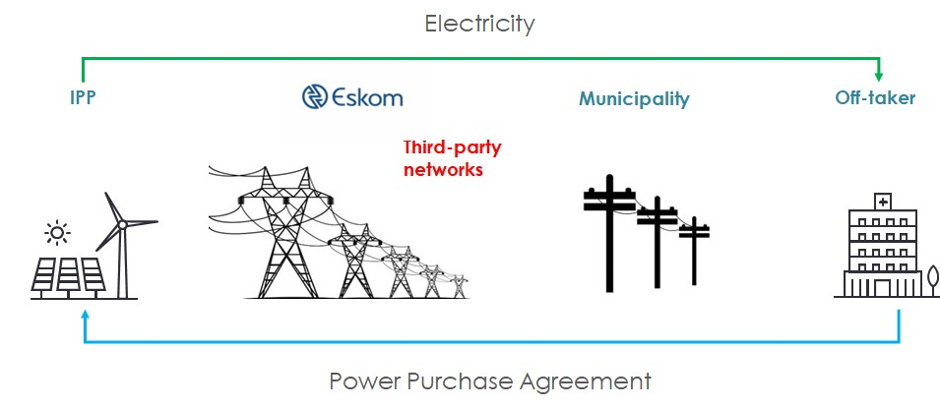

The purpose of this document is to provide a detailed guideline for the Municipality to establish processes to implement the rules and principles that will enable third-party wheeling transactions between Generators and Off-takers (i.e., in this case the municipal customer), while ensuring compliance with national policies and legislation, such as the Electricity Pricing Policy (EPP) and the Electricity Regulation Act (ERA). Third-party wheeling will enable customers and generators to buy and sell electricity from sources other than their licensed service provider (Licensee), which will promote customer choice. With the increasing global awareness of climate change and the drive towards carbon neutrality, municipalities must not hinder the growth of the green economy. The cost of renewable energy continues to decrease yearly, making wheeling an attractive method for municipal customers to transact with third-party generators. It is imperative for municipalities to develop tariffs and regulations to effectively regulate these transactions.

The annual high tariff increases and the current energy crisis resulting in frequent load shedding necessitates additional generation capacity. Wheeling offers a solution that allows the private sector to contract with electrical customers while ensuring that municipalities recover their cost of supply. Wheeling allows for the transmission of electricity from a third-party generator over the municipal grid to a customer, without the generator having to physically connect to the customer. The municipality acts as the intermediary between the generator and the customer, providing access to the grid and billing both parties for the use of the grid infrastructure. . The municipality can charge a wheeling tariff to the generator and customer, which covers the cost of using the grid infrastructure, including the transmission and distribution costs. This tariff is set at a level that ensures the municipality recovers its cost of supply while enabling green economic growth. In this way, wheeling provides a cost-effective solution for the private sector to contract with electrical customers, without the need for the generator to invest in their own transmission infrastructure.

The following are some of the benefits of third-party wheeling:

Financial and Economic Advantages:

* Revenue Generation: Third-party wheeling introduces new revenue streams through charges, fees, and connection costs. These funds contribute to local infrastructure development and community projects.
* Economic Growth: Encouraging private investments in generation stimulates job creation and overall economic activity within the municipality.
* Incentivizing Customer Retention: Offering green and cost-effective electricity choices incentivizes customers to remain connected to the municipality's grid.
* Local Economic Development: Projects within the municipality create job opportunities and foster economic growth.

Energy Security and Sustainability:

* Energy Security: Private generation projects diversify energy sources, reducing vulnerability to supply disruptions and load shedding.
* Decarbonization and Sustainability: Wheeling enables customers to access clean energy, aligning with sustainability targets and reducing carbon footprints.

Technological Advancement and Innovation:

* Technological Leadership: Partnering with private generators introduces advanced technologies and innovation, positioning the municipality as a technological hub.
* Flexibility and Customer Choice: Customers gain flexibility by sourcing energy from diverse generation facilities, enhancing energy procurement options and promoting customer choice.

Collaboration and Grid Enhancements:

* Collaboration and Knowledge Exchange: Partnerships with energy generators facilitate knowledge sharing, fostering a supportive energy ecosystem.
* Infrastructure Development: Private investments in generation can lead to shared grid infrastructure enhancements, benefiting both the municipality and energy projects.

Financial Efficiency and Strategic Positioning:

* Cost Efficiency: Wheeling potentially reduces customer electricity expenses, enhancing financial efficiency for consumers.
* Price Certainty: Long-term power purchase agreements via wheeling offer customers stable and predictable electricity costs over time.
* Optimized Procurement: Licensees can optimize their own procurement costs, enhancing financial performance.

Regulatory Compliance and Independence:

* Regulatory Compliance: Clear guidelines demonstrate commitment to regulations, enhancing the municipality's reputation and attracting further investment.
* Reduced Reliance on Eskom: Wheeling reduces dependence on external energy suppliers, promoting local energy independence.

Environmental and Reporting Benefits:

* Renewable Energy Certificates (RECs): Generators/customers can obtain RECs, showcasing their commitment to renewable energy.
* Sustainability Reporting: Customers using green power can leverage it for sustainability reporting and meeting environmental targets.

In light of these diverse benefits, municipalities are well-positioned to establish robust wheeling guidelines. These guidelines not only cater to customer needs but also align with local development strategies, technological advancements, and broader energy sector enhancements. Furthermore, distribution licensees' commitment to non-discriminatory grid access fosters a dynamic and sustainable energy landscape

There are various scenarios that can occur in third-party wheeling depending on whether the Eskom or municipality network are used, and if an energy trader is involved – this will affect the agreements required, tariffs used, and billing methodologies. See section 8 for the different scenarios.

# Legal & Regulatory Framework

🔍 ***Explanatory notes:***

*Compliance with legal requirements and indemnity provisions are crucial to ensure a fair and equitable electricity market. Municipalities play a pivotal role in administering electricity reticulation, and it is essential that they adhere to the relevant legislation and regulations.*

*This section provides an overview of the legal requirements for third-party access and open access transmission, including indemnity requirements and compliance with relevant legislation and regulations. It also discusses the technical requirements, the Constitution's requirements, and the conclusion that municipal adherence to the regulations and legal requirements is crucial to providing impartial, fair, and equitable services.*

*The key legislation that allows for third party wheeling is the Electricity Regulation Act (ERA), 2006 and soon to be published Third-Party Wheeling Rules by NERSA. Below are extracts that the municipality can utilize from the ERA. Third Party-Wheeling Rules by NERSA are yet to be fully developed at this stage (June 2023) and hence has not been included in the below. When these are rules are finalised, the below section may need to be aligned to the rules accordingly.*

**💡Illustrative example**

The Electricity Regulation Act, 2006 (Act No. 4 of 2006) or as amended requires that:

* The transmission, distribution, and trading function of electricity supply be separately licensed and that the transmission or distribution function shall provide non-discriminatory network access to all users of the transmission or distribution system.
* The current Act Section 15(2) also states “A licensee may not charge a customer any other tariff and make use of provisions in agreements other than that determined or approved by the National Energy Regulator (NERSA) as part of its licensing conditions”.
* The Electricity Regulation Act (ERA) states that “A transmission or distribution licensee must, to the extent provided for in the licence, provide non-discriminatory access to the transmission and distribution power systems to third parties” S22(3). Furthermore, in S22(4) the Act states that access must be provided on the conditions set out in the licence of the distributor as it relates to, but is not limited to the following:
  + Access being allowed or refused.
  + Compliance with any rule, code or practice made by the regulator.

The licence conditions consist of financial, legal, and technical conditions. There are various technical conditions mentioned in the licence but the one specifically applicable to wheeling is NRS 048 (quality of supply). The Municipality is thus obligated to allow third party access to the grid but must still adhere to its licence conditions.

According to the ERA, the Municipality may grant or refuse access (*may be subject to change if and when national third-party rules are implemented)* only where it lacks the necessary capacity, with written valid reasons given for such refusal, and that any party requesting information on network capacity and measures that would be necessary to reinforce the network may be charged a reasonable fee reflecting the cost of providing such information. It is therefore the stated intention of the Municipality to impose additional conditions on wheeling entities only insofar as it will ensure the quality of supply to its consumer base.

The additional requirements will be mostly technical in nature. The Municipality aims to develop the technical capacity with pilot projects and foresees these requirements being amended regularly. The municipality does not want to take unnecessary technical risks by enabling wheeling. The project will rely on standards already developed for embedded generators. This will ensure minimal technical risk for the Municipality and compliance with all relevant technical standards.

The ERA and NERSA's Transmission Grid Code and Distribution Network Code mandate non-discriminatory access to the grid for all customers, including transmission and distribution connected generators and loads, for energy delivery or export. However, third-party wheeling of energy is currently subject to the buyer being connected on a medium-voltage (MV) or higher-voltage network and being on a time-of-use (TOU) tariff. The customer whose account(s) the energy will be wheeled to must sign an amendment/addendum agreement to their Electricity Supply Agreement (ESA), and the generator must nominate the buyer(s) of the wheeled electricity in the Connection and Use-of-System Agreement (UoSA). If one of the parties buying the energy is located within a municipal network, the municipality would be the party to sign the amendment/addendum agreement with Eskom.

In addition to these requirements, there are several other requirements that need to be fulfilled for generators to be able to wheel electricity:

* All generators, whether private or public, must be licensed or registered to generate and supply the network with electricity. To ensure accelerated access to the open grid, the government has raised the threshold for private self- or distributed-generation power plants from 1MW to 100MW to only now having to be registered with NERSA, that is, not requiring a license.
* The generator must apply to Eskom or the Municipality (if within the Municipality grid) for grid connection and pay relevant determined charges.
* The customer whose account(s) the energy will be wheeled to must sign an amendment/ addendum agreement to their Electricity Supply Agreement to have the account adjusted for the wheeled energy based on the Gen-wheeling tariffs. If the Electricity Supply Agreement is not up to date, a new agreement must be signed.
* The generator must proceed with the connection, sign the "Connection and Use-of-System Agreement," and nominate the buyer(s) of the wheeled electricity in this agreement.
* The buyer(s) can be another Eskom customer, a municipality, or a customer within a municipal network. The buyer(s) will be required to sign an amendment/ addendum agreement.
* If one of the parties buying the energy is located within a municipal network, the municipality would be the party to sign the amendment agreement with Eskom (not the buyer) and must agree to allow the wheeling transaction.

In summary, the Municipality will allow non-discriminatory access to the municipal grid by third parties in full compliance with national legislation and the rules or codes published by the regulator. In addition, it will create requirements for third-party energy providers to ensure the municipal compliance to its licence conditions.

# Roles and Responsibilities of Stakeholders

🔍 ***Explanatory notes:***

*The section on the roles and responsibilities of stakeholders provides a comprehensive overview of the duties and obligations of key participants in the electricity wheeling process. Understanding the roles and responsibilities of each party is crucial for maintaining a reliable and secure grid, adhering to regulatory requirements, and fostering a transparent and fair environment. This section helps stakeholders comprehend their individual responsibilities, establishes accountability, and facilitates effective communication and cooperation throughout the electricity wheeling process. The Municipality play a vital role in this process by identifying stakeholders, engaging with them through regular communication and consultations, facilitating licensing and approval, establishing fair tariff structures, monitoring compliance, and collaborating with regulatory bodies. By effectively fulfilling these responsibilities, The Municipality ensure the successful implementation of the wheeling framework, promote customer choice, support private generation capacity, and maintain a reliable electricity supply within their jurisdiction.*

**💡Illustrative example**

Below are the roles and responsibilities of key stakeholders

* NERSA:
* Set guidelines for tariffs.
* Approve tariffs for transmission and distribution services, including the wheeling tariff.
* Approve applications for access to the grid by third-party generators and customers.
* Ensure compliance Municipality:
* Design tariffs for wheeling in line with a cost of supply study.
* Provide and maintain the local electricity distribution network.
* Approve or reject applications for third-party access and open access transmission.
* Ensure the safe and reliable operation of the grid, including compliance with relevant regulations and standards.
* Measure the consumption of the off taker.
* Apply appropriate billing for consumption and wheeling credits.
* Set and collect wheeling charges.
* Independent Power Producer (IPP)/ Generator:
* Construct, operate, and maintain electricity generation facilities.
* Sell electricity to customers and/or traders.
* Comply with relevant regulations and standards.
* Be responsible for ensuring the safety and reliability of their electricity generation facilities.
* Customer:
* Purchase electricity from the generator or trader.
* Comply with relevant regulations and standards.
* Install any necessary metering and control equipment on their premises.
* Trader/Aggregators if applicable:
* Trading is the buying and selling of electricity generated by *multiple* Independent Power Producers (IPPs) in many locations to multiple buys or off-takers in different locations facilitated by a Trader/Aggregators
* Purchase electricity from generators and sell it to customers.
* Arrange transmission services, if necessary.
* Comply with relevant regulations and standards.
* Eskom:
* Provide transmission services, if applicable.
* Coordinate with the Independent System and Market Operator (ISMO) to ensure the efficient operation of the grid.
* Comply with relevant regulations and standards.
* with relevant regulations and standards.
* TSO (TSO not yet formed and below is what is envisaged):
* The TSO, or Transmission System Operator, is responsible for the operation, maintenance, and development of the high-voltage transmission system.
* Their role includes ensuring the secure and reliable transmission of electricity across the grid.
* The TSO manages the flow of electricity, monitors grid stability, and coordinates with other stakeholders to maintain the integrity of the transmission system.
* They also facilitate the connection of new generators to the transmission system and oversee the dispatch of electricity.

# General Guidelines and Conditions

🔍 ***Explanatory notes:***

*The section on general guidelines and conditions establishes the overarching principles and regulations for the electricity wheeling process. The Municipality have the responsibility to develop clear guidelines that align with these principles and ensure compliance with the Electricity Regulation Act (ERA) and national third-party wheeling rules. They should regularly review and update the guidelines, provide clarity and guidance to stakeholders, facilitate effective communication, and monitor compliance.*

**💡Illustrative example**

The following general guidelines are applied by the Municipality:

* Rights of Access: The Municipality can connect customers (loads and generators) to the network based on their ability to do so, complying with relevant electricity regulations, transmission and distribution licenses, and electricity supply agreements.
* Use-of-System Charges: Third-party wheeling transactions cannot avoid use-of-system charges, and these charges must be non-discriminatory, treating customers supplied by the Licensee and those supplied through bilateral transactions equally.
* Incremental Charges: Additional connection and administration charges may be applied for third-party wheeling transactions.
* Accounting for Wheeled Energy: Since there is no direct flow of electrical energy between sites, the Licensee must account for the wheeled energy through a financial transaction. The energy usage is measured by the generator and the Licensee, and the Licensee includes it in the Off-taker's electricity bill.
* Contracting and Amendments: The acknowledgment of wheeled energy and the accounting mechanism is done through an amendment or addendum to the supply agreement between the Off-taker and the Municipality.
* Buyer of Wheeled Energy: Unless the Municipality has a Power Purchase Agreement (PPA) with a Seller not connected to their network, they are not the buyer of the Wheeled Energy.

Third-party wheeling of energy is allowed by the Municipality under the following conditions:

* Compliance with Legislative Instruments: All parties must comply with relevant legislation, including Acts, bylaws, Codes, and Licensee agreements.
* Generator Requirements: The generator must have a Code-compliant connection and a Connection and Use-of-System Agreement with the Licensee. They must also register with the National Energy Regulator of South Africa (NERSA) to comply with Schedule 2 of the Electricity Regulation Act (ERA).
* Off-taker Requirements: The Off-taker must sign an amendment or addendum to the electricity supply agreement with the Licensee to account for the Wheeled Energy.
* Licensing Requirements: Entities involved in transmitting or distributing power in South Africa require a NERSA-approved Transmission or Distribution License. Trading licenses are required for entities engaged in buying and selling electricity commercially. Resellers have specific conditions under the NERSA Resellers Guideline.
* Approval of Use-of-System Charges: Use-of-system charges raised by the Municipality must be approved by NERSA.
* Approval of Wheeling Credit Rate/Tariff: NERSA must approve the wheeling credit rate/tariff or transaction mechanism for accounting Wheeled Energy to ensure it does not impact the tariffs of other customers.
* Payment of Charges: The generator and Off-taker are responsible for paying all charges associated with the wheeling transaction.
* Additional Conditions: The Municipality may impose other conditions deemed necessary as long as they do not conflict with the established rules, ERA, Codes, and the Electricity Pricing Policy (EPP).
* NERSA licenced / registered: Only NERSA licenced / registered generators will be allowed to wheel.
* Limit on total capacity: The allocation of the Municipality’s wheeling capacity will be done on a basis to ensure that competitive market will prevail, and lowest possible prices can be achieved.
* Limit on capacity per applicant: A maximum export capacity allocation will be allowed per applicant for the initial period. This value cannot be exceeded unless approved by the Director. The Municipality will review this allocation when required.
* Minimum connection size of the off-taker: The off-taker must be connected to the Municipality’s Medium Voltage network and must be on a time-of-use tariff. This is not a hard limit, and the Municipality can decide on specifics.
* Revenue neutrality: The tariffs must be at least surplus (lost revenue – cost savings) neutral for the municipality i.e., the municipality will not be losing any existing revenue by allowing wheeling. Any additional charges for wheeling added by Eskom to the municipality’s account will be for the off-taker’s account.
* Billing reconciliation period: The billing will be reconciled on a monthly time-of-use basis. No banking will be allowed. This means that any kWh wheeled which exceed the power consumed by the off-taker in any monthly time-of-use period will be considered over wheeling. This is not a hard limit, and the Municipality can decide on specifics.

The conditions applicable if the generator is connected to the Municipal Grid.

* Generator tariff: The generator must be on the applicable time-of-use tariff for consumption. Access and Demand charges will apply in respect of own demand and in cases where network demand will be increased, based on wheeling kVA.
* Generator connection agreements: The generator must adhere to the generation connection requirements or Codes for the connection of the generation facility to the grid.
* Generator connection Voltage: Generators must connect at 11kV or higher to the Municipal Grid. The required connection size/tariff may be municipality specific depending on their defined rules and should match the Point of Utility Connection (PUC). This is not a hard limit, and the Municipality can decide on specifics.
* All embedded generation installations are fully compliant with the relevant regulations, standards, and specifications for the installation to be approved. Below is a (non-exhaustive) list of the most relevant regulations, standards, and specifications:
* Electricity Regulation Act 4 of 2006 and Electricity Regulation Amendment Act 28 of 2007
* South African Grid Codes (Distribution, Transmission and Renewable Power Plants)
* Occupational Health and Safety Act 85 of 1993
* Municipal Electricity Supply By-law
* SANS 10142: All Parts
* SANS 474/NRS 057: Code of practice for electricity metering
* NRS 097 Series

The technical standards above are explained in detail in **Annexure A.**

# Contractual Arrangements

🔍 ***Explanatory notes:***

*The section on contractual arrangements provides guidance on the necessary agreements and contracts involved in the third-party wheeling process. The Municipality have a key role in managing these contractual arrangements and ensuring their effectiveness. Some key actions that The Municipality need to undertake include:*

* ***Identify Contractual Arrangements:*** *The Municipality should identify the specific contractual arrangements required for the third-party wheeling process. This includes agreements between the Municipality, the generator, the off taker/customer, and any intermediaries or aggregators/traders involved. Identifying the necessary contracts is essential for establishing clear rights, responsibilities, and obligations for all parties involved.*
* ***Use Contract Templates:*** *The Municipality can utilize existing contract templates available for third-party wheeling as a starting point. These templates provide a structured framework that can be tailored to suit the specific needs and requirements of the municipality. By using standardized templates, The Municipality can ensure consistency and efficiency in the contracting process. Below are links to standard contract templates and user guide which can be adapted by The Municipality.* [Wheeling | 110% Green (westerncape.gov.za)](https://www.westerncape.gov.za/110green/energy/wheeling)
* ***Customize Contracts:*** *The Municipality should customize the contract templates to make them applicable to the municipality's specific circumstances. This includes incorporating relevant details, such as the municipality's name, specific tariff structures, billing arrangements, and any additional provisions or requirements that align with the municipality's regulations and policies.*
* ***Internal Legal Review:*** *The Municipality should involve the internal legal department or seek legal expertise to review and validate the customized contract templates. This step ensures that the contracts are legally sound, enforceable, and protect the interests of the municipality and all parties involved. Legal review helps identify any necessary modifications or additions to the contracts for compliance with relevant laws and regulations.*
* ***Negotiate and Finalize Contracts:*** *The Municipality should engage in negotiations with the relevant stakeholders to finalize the contractual arrangements. This involves discussing the terms and conditions, resolving any potential conflicts or concerns, and reaching mutually acceptable agreements. Once the negotiations are completed, the contracts should be finalized, signed, and properly executed by all parties involved.*
* ***Contract Management:*** *The Municipality are responsible for the ongoing management and monitoring of the contractual arrangements. This includes ensuring compliance with the agreed-upon terms, resolving any disputes or issues that may arise, and periodically reviewing and updating the contracts as necessary to reflect changing circumstances or regulatory requirements.*

*By identifying contractual arrangements, using templates, customizing contracts, involving the legal department, negotiating and finalizing agreements, and managing the contracts effectively, The Municipality contribute to the establishment and smooth operation of the third-party wheeling process. Their actions help create a transparent and fair contractual framework that safeguards the interests of all parties involved.*

**Contract Development User Guide and Checklist**

A Contract Development user guide developed by the Western Cape Government [Wheeling | 110% Green (westerncape.gov.za)](https://www.westerncape.gov.za/110green/energy/wheeling) is a comprehensive document that focuses on providing guidance for municipalities involved in the third-party wheeling of electricity. It specifically addresses the standard agreements related to electricity wheeling. Within this user guide, there is a checklist that outlines the essential elements that should be present in the various contractual agreements associated with wheeling. By referring to this checklist, stakeholders can ensure that their wheeling agreements encompass all necessary components, contractual obligations, and operational considerations. This report equips users with the knowledge they need to ensure their various agreements are thorough and all encompassing. The checklist can be utilised by management to ensure completeness and accuracy of the various agreements. In order to accelerate the deployment of electricity third-party wheeling and to reduce administration and costs thereof for municipalities, the Western Cape Government have developed the following standardised agreements in a manner that can be customised according to each municipality’s needs:

• Standard Use-of-Systems Agreement for Electricity Wheeling (“UoSA”);

• Connection Agreement; and

• Supplemental Electricity Supply Agreement (“Supplemental ESA”).

**💡Illustrative example**

The following contracts are required for third-party wheeling and can vary depending on if Eskom is involved or not.:

* Agreement with the IPP Generator:
* The generator must enter into an agreement with the Network Service Provider (Licensee or Municipality) that outlines the terms and conditions for connection to and use of the Network.
* This agreement includes the Connection and Use-of-System Agreement, which may specify details about the Buyer of the Wheeled Energy.
* It addresses technical and operational aspects such as compliance with codes, metering requirements, maintenance responsibilities, and safety protocols.
* These requirements ensure that the generator meets legal and technical standards, operates within the regulatory framework, and maintains the integrity and reliability of the Network.
* Then from a municipal contractual perspective, the generator signs a Distribution, Connection and Use-of-System Agreement (DCUoSA) with Eskom (if Eskom is wheeling), which falls outside the scope of this Guide. For purposes of accounting for the electrical energy needing to be distributed to the Off-taker connected to the Municipal Distribution System, the generator (or trader) will also have to sign a Standard Use-of-Systems Agreement for Electricity Wheeling (“UoSA”) with the Municipality.
* Agreement with the Off-taker:
* An agreement is needed with the Buyer of the Wheeled Energy to account for the energy flowing onto the Licensee’s Network, but not owned by the Licensee.
* This can be achieved through an amendment or addendum to the existing supply agreement known as the Supplemental Electricity Supply Agreement (ESA).
* The Off-taker must enter into an Amendment/Addendum to the Electricity Supply Agreement (ESA) with the Licensee, specifying the terms and conditions of the Wheeled Energy supply and accounting.
* The Off-taker will also typically sign a Power Purchase Agreement (PPA) with the IPP or Trader. Key concepts in this regard are:
  + **A Corporate PPA** is a long-term contract that allows a company to buy electricity directly from a generator, either on-site or off-site.
  + **A virtual PPA**: is a type of corporate PPA where the renewable energy generator and the corporate energy consumer do not physically exchange electricity. Instead, the renewable energy generator sells the energy generated into the wholesale electricity market, and the corporate energy consumer purchases Renewable Energy Credits (RECs) or Guarantees of Origin (GOOs) from the generator. The corporate energy consumer can then use these RECs or GOOs to meet their own renewable energy targets or offset their carbon emissions.
  + **A sleeved PPA** is similar to a virtual PPA, but the difference is that the renewable energy generated is not sold into the wholesale electricity market. Instead, a third-party intermediary, known as a "sleeve provider," (also known as an energy trader or retailer) purchases the energy generated by the renewable energy system and sells it to the corporate energy consumer. The sleeve provider acts as an intermediary between the generator and the corporate energy consumer, facilitating the transaction and taking on the risk associated with the fluctuating wholesale energy market prices.
* Agreement with an Intermediary (Trader or Corporate Entity):
* If the Buyer is a Trader or Corporate Entity, the Licensee and off-taker may choose to contract with them.
* Agreement between Transmission and Distribution Licensees:
* In cases where wheeling occurs across both transmission and distribution networks, an agreement between the two Licensees is necessary.
* This agreement acknowledges the wheeling from a generator connected to the transmission network and a customer connected to the distribution network.
* Both Licensees may need to share metering and billing information with the generator and the Off taker to facilitate the reconciliation of the Wheeling Credit/Tariff.
* These agreements ensure compliance, establish responsibilities, and enable proper tracking, billing, and reconciliation processes for the third-party wheeling transaction.
* This also known as the Amended Supply Agreement between the Transmission and Distribution Licensees.

The scenarios section deals with additional graphical guidance on how the various contracts explained above work practically. In addition, below is guidance on the various agreements and estimated timelines. Please note that the timeframes mentioned are general estimates and can vary depending on the specific circumstances, regulatory frameworks, and complexities involved in each agreement. It is essential to consult with legal professionals and stakeholders involved to determine realistic timelines for concluding wheeling agreements in your specific context.

|  |  |  |
| --- | --- | --- |
| **Agreement** | **Guidelines:** | **Timeframe:** |
| Agreement with the Generator: | Define the terms and conditions for the generator to wheel electricity to a specific location or off-taker. | The negotiation and drafting of the agreement with the generator can typically take several weeks to a few months, depending on the complexity of the project, the availability of both parties, and any necessary regulatory approvals. The aim should be to finalise the agreement in 4 to 8 weeks. |
| Specify the wheeling charges, payment terms, and invoicing procedures. |
| Determine the technical requirements, such as voltage levels, power factor, and metering arrangements. |
| Address the rights and obligations of the generator and the wheeling entity. |
| Include provisions for scheduling, curtailment, force majeure events, and dispute resolution mechanisms. |
| Agreement with the Off-taker: | Establish the terms and conditions for the off-taker to receive electricity through wheeling from a specific generator. | Similar to the agreement with the generator, the negotiation and drafting of the agreement with the off-taker can typically take several weeks to a few months, depending on the complexity of the project, the availability of both parties, and any necessary regulatory approvals. The aim should be to finalise the agreement in 4 to 8 weeks. |
| Define the wheeling charges, payment terms, and invoicing procedures. |
| Determine the technical requirements, such as voltage levels, power quality, and metering arrangements at the off-taker's location. |
| Address the rights and obligations of the off-taker and the wheeling entity. |
| Include provisions for scheduling, curtailment, force majeure events, and dispute resolution mechanisms. |
| Agreement with an Intermediary (Trader or Corporate Entity): | Establish the terms and conditions for an intermediary entity, such as a trader or corporate entity, to facilitate the wheeling arrangement between the generator and the off-taker. | The negotiation and drafting of the agreement with an intermediary can vary depending on the complexity of the arrangement, the involvement of multiple parties, and any necessary regulatory approvals. It can typically take between 4 to 8 weeks. |
| Define the roles and responsibilities of the intermediary in coordinating the flow of electricity and managing financial settlements. |
| Specify the payment terms, remuneration mechanisms, and transactional procedures. |
| Address the rights and obligations of the intermediary and the wheeling parties. |
| Include provisions for scheduling, curtailment, force majeure events, and dispute resolution mechanisms. |
| Agreement between Transmission and Distribution Licensees: | Define the terms and conditions for the transmission licensee (responsible for the bulk electricity transportation) and the distribution licensee (responsible for delivering electricity to end-users) regarding the wheeling of electricity between their respective networks. | The negotiation and drafting of the agreement between transmission and distribution licensees can involve complex technical and regulatory considerations. The timeframe can vary significantly depending on the jurisdiction, regulatory processes, and any necessary consultations. It should range between 2 to 4 weeks. |
| Specify the wheeling charges, payment terms, and settlement mechanisms. |
| Determine the technical requirements, grid connectivity standards, and metering arrangements. |
| Address the rights and obligations of both licensees in ensuring reliable and efficient electricity transmission. |
| Include provisions for scheduling, system operations, grid maintenance, and dispute resolution mechanisms. |

# Metering and Data

🔍 ***Explanatory notes:***

*The section on metering provides guidance on the metering requirements and considerations in the context of third-party wheeling. The Municipality play a crucial role in ensuring proper metering practices and compliance with relevant standards are adhered to by the relevant stakeholders within the wheeling transaction. It is worth noting the significance of two specific standards in South Africa:*

* ***SANS 474/NRS 057:*** *Code of practice for electricity metering: This South African national standard establishes a code of practice for electricity metering. It outlines the requirements for the installation, commissioning, operation, maintenance, and management of electricity metering systems. The standard applies to all types of electricity meters used for billing purposes by Network Service Providers (NSPs) or other relevant parties. The Municipality need to be aware of this standard and ensure that metering practices within their municipality align with its requirements.*
* ***SANS 473 (AMR meters):*** *SANS 473 refers to the standard for Automated Meter Reading (AMR) systems for large power users in South Africa. This specification specifically applies to AMR systems used by large power users as defined by the relevant electricity supply authority. It covers the requirements for AMR systems but does not encompass the communication system between the AMR meter and the remote master station.*

*Key actions that The Municipality need to undertake regarding metering include:*

* ***Familiarize themselves with Metering Standards:*** *The Municipality should familiarize themselves with the relevant metering standards, including SANS 474/NRS 057 and SANS 473. They should understand the requirements and guidelines outlined in these standards to ensure compliance within their municipality.*
* ***Ensure Proper Meter Installation****: The Municipality should ensure that meters are installed correctly and in accordance with the prescribed standards. This involves working closely with metering service providers to verify the accuracy and reliability of the installed meters.*
* ***Implement Meter Data Management:*** *The Municipality need to establish effective meter data management practices. This includes processes for collecting, validating, storing, and analyzing meter data. Robust meter data management enables accurate billing, efficient energy management, and effective monitoring of third-party wheeling transactions.*
* ***Metering Audits and Compliance:*** *The Municipality should conduct periodic metering audits to verify compliance with the established standards and regulations. Audits help identify any non-compliance issues and ensure that metering practices align with industry best practices and regulatory requirements.*

*By familiarizing with metering standards, ensuring proper meter installation, implementing effective meter data management, conducting periodic maintenance and audits, and ensuring compliance with relevant standards, The Municipality contribute to the accurate and reliable metering of electricity in the context of third-party wheeling. Proper metering practices are essential for fair and transparent billing, efficient energy management, and overall success of the wheeling process.*

*Using smart metering for third-party wheeling energy transactions offers several significant advantages and plays a crucial role in ensuring the success and efficiency of the process. Key reasons why smart metering is essential in the context of third-party wheeling:*

* ***Accurate Measurement and Billing****: Smart meters provide highly accurate and real-time measurements of energy consumption. This accuracy is crucial in third-party wheeling, as it ensures that the energy consumed by the off-taker is precisely measured, and the corresponding billing is fair and transparent. Smart meters eliminate the need for manual meter reading, reducing the chances of human errors or discrepancies in billing.*
* ***Time-of-Use (TOU) Tariffs:*** *Smart meters enable the implementation of Time-of-Use (TOU) tariffs, where electricity prices vary based on the time of day or the demand on the grid. TOU tariffs can incentivize off-takers to adjust their energy usage patterns, which can help balance the grid and reduce peak demand. This flexibility is especially valuable in the context of third-party wheeling, as it encourages efficient energy consumption.*
* ***Data Transparency and Visibility:*** *Smart meters provide a wealth of data that can be accessed remotely and in real-time. This data transparency and visibility benefit all parties involved in the third-party wheeling process, including the generator, off-taker, and the municipality. It enables better monitoring of energy flows, allows for accurate billing, and facilitates effective decision-making for energy management and optimization.*
* ***Load Profiling and Forecasting:*** *With smart metering, load profiling and forecasting become more precise. Utilities and off-takers can analyze historical consumption patterns and make informed predictions about future energy demands. This capability is vital for planning and ensuring the reliable supply of electricity in the context of third-party wheeling, where energy flows may vary depending on the contractual agreements.*
* ***Demand Response:*** *Smart meters support demand response initiatives, allowing off-takers to adjust their energy consumption during peak periods or when electricity prices are high. By participating in demand response programs, off-takers can contribute to grid stability and reduce their energy costs. This flexibility aligns well with the objectives of third-party wheeling, where optimizing energy usage is essential.*
* ***Remote Disconnect/Reconnect****: In situations where there are contractual issues or when a customer needs to be disconnected from the network temporarily, smart meters facilitate remote disconnect and reconnect capabilities. This feature ensures efficiency in managing and resolving any disputes or contractual changes in third-party wheeling arrangements.*
* ***Fraud Detection and Security****: Smart meters can detect irregularities or tampering, aiding in the prevention of energy theft and ensuring the security of the energy supply chain. In third-party wheeling, where multiple parties are involved, smart metering enhances the overall security of the energy transactions and helps maintain the integrity of the system.*

*In order to make use of the valuable data from the smart meters, the Municipality may need to consider investing in a smart metering system. A smart meter system, also known as an Advanced Metering Infrastructure (AMI) system, is a comprehensive and integrated network of smart meters and communication technologies that enable two-way communication between utility providers and consumers. It is a modernized metering solution that goes beyond traditional metering by incorporating advanced technology and data management capabilities.*

**💡Illustrative example**

Metering plays a crucial role in the measurement and billing of electricity for embedded generation and wheeling arrangements. It ensures accurate recording of energy consumption, facilitates fair billing, and enables effective management of the power system. This section provides an overview of metering requirements for embedded generation and wheeling, including the concepts of 4 quadrant metering and various metering components.

To ensure precision in measurement, all Point of Utility Coupling (PUC) points should be metered on the same Automated Meter Reading (AMR) platform. This centralized approach eliminates discrepancies and enhances the accuracy of metering data, providing a reliable basis for billing calculations.

Furthermore, it is important to note that the cost associated with metering equipment and ancillary services should be borne by the wheeling consumer. This ensures a fair distribution of expenses and encourages responsible energy consumption practices among participants in the wheeling arrangement.

Generators wheeling energy into the municipal distribution network must install a municipal approved bi-directional AMI meter at the point of generation at the generator’s cost. The Off-taker receiving wheeled energy must also install an AMI meter. The meter and AMI system for wheeling will need to comply to the SANS 474 and the NRS 049 respectively.

Below are some key items to understand in order to conceptualise the critical metering and coupling points for an illustrative wheeling network:

* Point of Common Coupling (PCC):

*The electrical node, typically a busbar, on the Network Service Provider's network, electrically nearest to the Embedded Generation’s facility, at which more than one customer is or could be connected or metered.*

* Point(s) of Connection (POC):

*The electrical node(s) on the Network Service Provider's network where the Embedded Generator's electrical equipment is physically connected to the Network Service Provider's electrical equipment.*

* Point of Utility Coupling (PUC):

*The PUC may be located near the Point of Connection or may be another point(s) within the Embedded Generator's facility between the Point of Generator Connection and Point of Connection.*

* Point of Generator Connection (PGC):

*The circuit-breaker and associated ancillary equipment that connects a generator to any electrical network. The PGC is the circuit-breaker electrically closest to the generator.*

* Point(s) of Supply (POS):

*The point(s) on the Network Service Provider's network from where electricity is supplied to the Embedded Generator by the Network Service Provider, or from where the Embedded Generator supplies electricity to the Network Service Provider.*

* Renewable Power Plant (RPP):

*A unit or a system of generating units producing electricity based on a primary renewable energy source.*

The diagram below depicts the locations of the critical metering and coupling points illustratively on a wheeling network:



The following metering and equipment are key to ensure accurate and valid metering for all stakeholders involved in the wheeling transaction

* **Current Transformers -** Metering circuits will use Class 0.2 metering Current Transformers (CTs) as a minimum, with Class 0.2 metering CTs being preferred, the burden rating (the maximum load that can be applied) of the CT must be correctly specified for the application in order to maintain the integrity of the metering circuit.
* **Voltage Transformers -** Voltage transformers (VTs) will be specified in accordance with NRS 030. Metering and measurement circuits will use VTs of accuracy class 0.2. The VTs may not be overburdened to ensure accuracy within class definitions.
* **Meters -** The meter will also be an electronic, programmable energy meter capable of recording import and export active energy and reactive energy in Q1, Q2, Q3 and Q4. The recording period will be programmable for 5, 10, 15, 30- and 60-minute periods. The profile data will be stored in a non-volatile memory on the meter.The accuracy class requirements for a metering point that consists of a meter(s) and associated instrument transformers, are determined by the nominal size of the load, expressed in terms of KVA, and are as specified in SANS 474 table 1.

|  |  |  |  |  |
| --- | --- | --- | --- | --- |
| **Load** | **Accuracy Class** | | | |
| **Active Energy Meter** | **Reactive Energy Meter** | **Current Transformer** | **Voltage Transformer** |
| >100 MVA | 0,2S | 1 | 0,2 * | 0,2 |
| 10 MVA to < 100 MVA | 0,5S | 2 | 0,2** | 0,2 |
| 1 MVA to < 10 MVA | 1 | 2 | 0,5 | 0,5 |
| 100 KVA to < 1 MVA | 1 | 3 | 0,5 | 0,5 |
| < 100 KVA | 2 | 3 | 1 | - |
| * No type test standard available yet | | | | |
| ** Class 0,5 is acceptable at the lowest ratio of a multi-ratio current transformer | | | | |

* **Quadrant Metering:** Quadrant metering involves the classification of active energy (useful power, measured in kW (kilo-watt hours)) and reactive energy (useless power, measured in kVAr (kilovolt-amperes reactive)) consumption based on the power factor (the ratio between the useful and useless power) and direction of energy flow. A capacitor opposes a change in voltage while an inductor opposes a change in the current. A lagging power factor signifies that the load is inductive. A leading power factor signifies that the load is capacitive.
* The four quadrants are defined as follows:
  + Quadrant 1: Active energy is import (+), reactive energy is inductive, and the power factor is lagging.
  + Quadrant 2: Active energy is export (-), reactive energy is capacitive, and the power factor is leading.
  + Quadrant 3: Active energy is import (+), reactive energy is inductive, and the power factor is lagging.
  + Quadrant 4: Active energy is import (+), reactive energy is capacitive, and the power factor is Leading.

The metering arrangement adopted per wheeling application will depend on the specific conditions of the wheeling agreement. The following metering philosophy will, however, apply to all wheeling interconnections.

* Tariff metering: Tariff metering, owned and maintained by the Utility Network Service Provider (i.e. the Municipality), is installed through a main and check meter arrangement at the Point of Utility Connection (PUC). It is used to bill the Wheeling Partner for import and export consumption. The cost of the metering installation and ancillary equipment will be borne by the wheeling consumer.
* Back-up metering: The Customer or Off-taker may install a check meter for verification and audit purposes.
* Independent metering: If the Customer or Off-taker does not want to use the Utility Network Provider's infrastructure, they are responsible for the installation, maintenance, and operation of their own metering system, complying with the relevant standards.
* Tariff meters for selling energy: Tariff meters for selling electrical energy to the Utility Network Provider should measure energy exported by the Wheeling Partner, excluding the power consumed by its auxiliaries. The Utility Network Provider may bill the Customer or Off-taker for the energy consumed as import energy.
* Remote downloading: All meters should include facilities for automated remote downloading by service providers. Meters are energized via their auxiliary input, preferably by a 110V DC supply or a 240V AC supply. Class 0.5 meters without an auxiliary input facility may be energized through the normal 110V VT supply.
* Utility Network Provider's metering system: In cases where the Utility Network Provider's metering system is installed within a customer or Wheeling consumers substation or industrial plant, the Utility Network Provider's metering equipment will be limited to the metering panel and associated equipment.

Smart metering, AMR platforms and data exchange:

* Overall, a well-designed and cost-effective metering infrastructure, supported by a comprehensive AMI platform, is essential for the success of embedded generation and wheeling, providing accurate data for billing and promoting efficient use of energy resources.
* Wheeling data: For each external wheeling contract, Eskom offsets the wheeled energy from the metered supply to the Municipality. The load proﬁle of this subtracted energy is supplied in accordance with tripartite agreement and needs to be processed by the billing system.
* The connection will be secured by Transport Layer Security (TLS) and the data transferred will be signed by public-private keys to ensure that the content can be authenticated even if it was handled by a third party.
* The data exchange will be in accordance with NRS 049-5-2. NRS 049-5-2 refers to the National Ratification Standard (NRS) and has a deep focus on Data Exchange. The standard defines the data exchange protocols and formats to be used when communicating with smart electricity meters. It ensures that the data exchanged between the meters and external systems (e.g., utility providers' data management systems) adhere to standardized formats, enabling seamless integration and data interoperability. In the context of third-party wheeling or any other electricity-related transactions, adherence to NRS 049-5-2 is crucial to ensure the accuracy, reliability, and compatibility of smart electricity meters. Compliance with this standard enables transparent and consistent data exchange, which is essential for accurate billing, efficient energy management, and overall integrity of the electricity supply chain.
* The data transferred will be in accordance with the CIM (Common Information Model) model speciﬁed in IEC 61968-9 and the data will be signed with clear text JAdES (JSON Advanced Electronic Signature) or XAdES (XML Advanced Electronic Signature). (JSON Advanced Electronic Signature or XML Advanced Electronic Signature). To further elaborate:
  + This refers to the data exchange and security protocols used in the context of smart metering or energy management systems.
  + CIM Model (Common Information Model) - IEC 61968-9: The Common Information Model (CIM) is an international standard (IEC 61970 series) that provides a standardized way to represent and exchange information related to electrical systems and energy management. IEC 61968-9 specifically focuses on the "Application Integration at Electric Utilities - System Interfaces for Distribution Management - Part 9: Interfaces for Meter Reading and Control”.
  + The CIM model defines a standardized data structure and format that allows seamless communication and data exchange between different components of the electrical network, such as smart meters, data management systems, and utility providers. By adhering to the CIM model, the data exchanged between these components can be easily interpreted and utilized, ensuring interoperability and efficient energy management.
  + JAdES (JSON Advanced Electronic Signature) and XAdES (XML Advanced Electronic Signature): JAdES and XAdES are two digital signature formats that provide data integrity and authenticity when exchanging information electronically. These signature formats are used to sign the data being transferred, ensuring that the data remains unchanged and originated from the intended sender.
  + JAdES: JSON Advanced Electronic Signature uses the JSON (JavaScript Object Notation) data format for representing the electronic signature. JSON is a lightweight and widely used data interchange format. JAdES allows the signature to be attached to JSON data, providing secure authentication and verification of the data's origin and integrity.
  + XAdES: XML Advanced Electronic Signature uses the XML (eXtensible Markup Language) data format for representing the electronic signature. XML is a popular markup language used for data representation and exchange. XAdES allows the signature to be attached to XML data, ensuring the security and reliability of the data during transmission.
  + By using clear text JAdES or XAdES signatures, the data exchanged in smart metering or energy management systems can be securely signed and verified, protecting against data tampering or unauthorized access. This ensures the integrity and authenticity of the data, providing a trusted and reliable communication framework for all parties involved in the energy supply chain.
  + The security key exchange should be done for each separate contract to ensure integrity.

# Tariffs, Charges and Billing

🔍 ***Explanatory notes:***

*The section on Tariffs and Billing provides guidance on the establishment of tariffs and billing processes in the context of third-party wheeling and includes proposals for standardizing the calculation of wheeling and network charges (as opposed to individual point-to-point wheeling charges). The Municipality play a crucial role in ensuring the compliance of tariffs and billing practices with relevant regulations, codes, and standards. It is worth noting the following considerations:*

* ***Compliance with Regulations and Codes:*** *The Municipality must ensure that the tariffs and billing practices align with all applicable regulations, codes, and standards. This includes compliance with the Electricity Regulation Act (ERA), any relevant third-party wheeling rules (when published), and other industry-specific guidelines. It is important to stay updated on any changes or updates to these regulations and codes to ensure ongoing compliance. Below are useful links*
* [***https://www.energy.gov.za/files/policies/ELECTRICITY%20REGULATION%20ACT%204%20OF%202006.pdf***](https://www.energy.gov.za/files/policies/ELECTRICITY%20REGULATION%20ACT%204%20OF%202006.pdf)
* [www.energy.gov.za/files/policies/Electricity%20Pricing%20Policy%2019Dec2008.pdf](http://www.energy.gov.za/files/policies/Electricity%20Pricing%20Policy%2019Dec2008.pdf)
* <https://www.nersa.org.za/wp-content/uploads/2022/01/RSA-Distribution-Tariff-Code-Vers-6.2.pdf>
* [***https://www.eskom.co.za/distribution/wp-content/uploads/2022/03/RSA-Distribution-Code-Definitions-Ver-6.2.pdf***](https://www.eskom.co.za/distribution/wp-content/uploads/2022/03/RSA-Distribution-Code-Definitions-Ver-6.2.pdf)
* [***https://www.cityenergy.org.za/uploads/resource_451.pdf***](https://www.cityenergy.org.za/uploads/resource_451.pdf)
* ***NERSA Approval:*** *In some cases, The Municipality may be required to obtain approval from the National Energy Regulator of South Africa (NERSA) for the establishment of tariffs or any significant changes to existing tariffs. It is essential to understand the regulatory requirements and processes for tariff approval and engage with NERSA when necessary.*
* ***Compliance with mSCOA****: The Municipality must ensure compliance with the Municipal Standard Chart of Accounts (mSCOA). This provides a consistent and standardized framework for financial reporting and accountability. The Municipality need to align the tariff and billing processes with the mSCOA guidelines to ensure accurate financial recording and reporting.*

*Key actions that The Municipality need to undertake regarding tariffs and billing include:*

* ***Cost of supply studies:*** *Cost of supply studies refer to assessments conducted to determine the costs associated with providing electricity services within a municipality's distribution network. These studies aim to analyse and quantify the various components involved in the delivery of electricity, such as infrastructure maintenance, operational expenses, administrative costs, and investment in network upgrades. The Municipality play a critical role in conducting cost of supply studies and ensuring their accuracy and relevance. The following are key actions that The Municipality need to undertake in this regard. For support on please see link below:*

[Cost of Supply Studies - Embedded Generation Resource Portal (sseg.org.za)](https://www.sseg.org.za/cos/)

*Tariffs must be driven by the municipality’s own cost of supply studies as the results are dependent on their customer’s profile (see above definition of cost of supply study and link for more information, also see SALGA and SEA websites). It is recommended that tariffs are unbundled for transparency and understanding purposes.*

*See below diagrams taken regarding the creation of tariffs from the NERSA consultation paper of August 2023:*

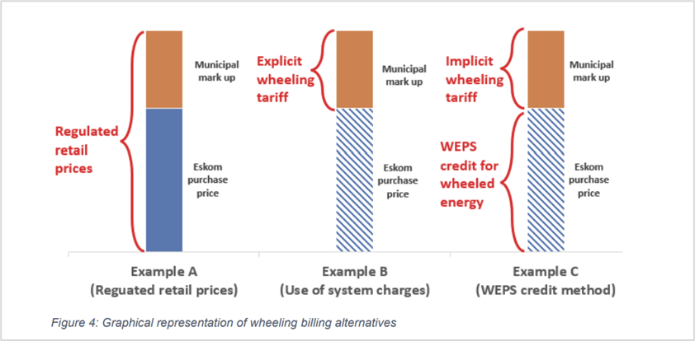

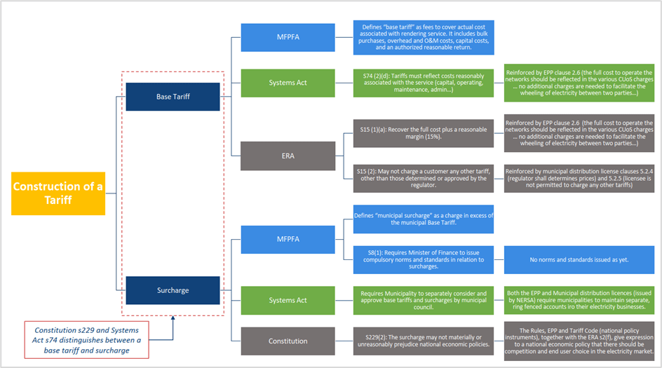

* ***Tariff Design and Approval:*** *The Municipality should establish a transparent and fair tariff structure that reflects the costs associated with the provision of electricity services. Tariffs should be designed in accordance with regulatory requirements and the principles of cost recovery. It is important to engage with relevant stakeholders and obtain the necessary approvals for tariff implementation.*
* ***Billing Accuracy and Transparency:*** *The Municipality need to ensure that billing processes are accurate, transparent, and aligned with the established tariffs. This involves implementing robust meter reading, data validation, and billing verification procedures. Billing statements should provide clear and detailed information to customers, including the breakdown of charges and any applicable taxes or levies.*
* ***Customer Dispute Resolution:*** *The Municipality should have mechanisms in place to address customer disputes related to tariffs and billing. This includes establishing procedures for handling customer complaints, conducting investigations when necessary, and resolving disputes in a timely and fair manner.*
* ***Compliance Monitoring:*** *The Municipality need to monitor and assess the compliance of tariffs and billing practices on an ongoing basis. This involves regular reviews of billing processes, conducting internal audits, and addressing any identified non-compliance issues. It is important to maintain accurate records and documentation to demonstrate compliance with regulatory requirements.*

*By ensuring compliance with regulations, codes, ERA, third-party wheeling rules (when published), obtaining NERSA approval when necessary, and aligning with the mSCOA guidelines, The Municipality will contribute to fair and transparent tariff and billing practices in the context of third-party wheeling. This promotes customer confidence, regulatory compliance, and efficient financial management within the municipality.*

**💡Illustrative example**

There are two tariff structures currently being used in South Africa:

**Option 1: Wheeling Credit Rate/Tariff = Time-of-Use Energy Purchase Price excluding technical losses**

* The Wheeling Credit Rate/Tariff refers to the rate in c/kWh at which the Wheeled Energy is credited to the Off-taker's electricity bill based on the Licensee Avoided Cost. This is a tariff charge based on negative kWhs for Wheeled Energy that has been supplied to the Network by the generator and need to be “given back” to the Buyer of the energy who pays the generator directly for the Wheeled Energy.
* A credit is therefore given back to the customer for the wheeled energy i.e., for example a charge of R1 per kWh, with a credit of R0.20 per kWh given back to the customer – both these amounts will be shown on the customer invoice.
* Before implementing the Wheeling Credit Rate/Tariff, it must be justified by the Licensee for approval by NERSA. This is not a commercial arrangement for a payment of energy by the Licensee, but a refund to the customer for energy exported at one point of the Network which the Licensee has used and, therefore, needs to give it back to the Buyer.
* NERSA's approval ensures that the Wheeling Credit Rate/Tariff is not discriminatory, is based on fair and equitable principles, promotes regulatory compliance and provides confidence in the tariff to be applied.
* Using an approved Wheeling Credit Rate tariff provides clarity and transparency regarding the financial aspects of the wheeling arrangement.
* It serves as a benchmark for calculating the value of the Wheeled Energy and ensures that the Off-taker receives proper compensation for the Wheeled Energy.
* The Wheeling Credit Rate/Tariff shall be based on Avoided Cost using the following formula:
  + The energy purchase price is based on the approved Distributor’s Avoided Costs.
  + The technical line losses shall be based on the cost-of-supply study results.
  + The energy purchase price to be used is based on active energy charges payable at the wholesale level.
  + That the Licensee will have the choice to do half-hourly, hourly or monthly time-of-use reconciliation. Over-time this should, however, evolve to be at least hourly.

**Option 2: Separating Wheeled Energy on the bill from Licensee supplied energy**

* This methodology requires a splitting of the kWh – those purchased by a Buyer from the Licensee, and those purchased through a wheeling transaction.
* This methodology requires unbundled tariffs reflecting the different services being provided.
* To create an unbundled tariff, a cost of supply study must be done by the Municipality.
* All Use-of-system charges based on a cost of supply study will be raised on the delivered energy, whether raised as a c/kWh charge or other types of charges. If a cost of supply is not available, then the Use-of-system charges as approved by NERSA will be utilised in the methodology by the Licensee.
* Only energy charges will be raised on the energy supplied by the Licensee.
* The wheeling transaction will be applied using the following formula:
  + Use-of-system charges for the total energy = Total kWh x Use-of-system kWh + Demand charges (kVA or kW) x demand + service and administration charges + contribution to subsidies/surcharges + ancillary services + technical losses
* Energy charge for Licensee supplied energy = (Total energy – Wheeled Energy) x unbundled energy charge
* In this example the ‘’credit’’ has been built into the rate per kWh (bundled tariff) i.e., the customer is charged R0.80 per kWh (R1 minus R0.20 credit = effective rate of R0.80). Only the rate of R0.80 is shown on the bill.

Service and administration costs

If there are additional administration costs associated with the wheeling transaction, the Licensee (i.e. the Municipality) shall be entitled to recover such costs for the wheeling transaction.

* The justification of the fair allocated costs and the tariff charges shall be done through a cost of supply study considering metering, billing, reconciliation, data management, and other related administrative costs.
* Fair charges shall be justified by the Licensee based on the above costs and approved by NERSA to cover the additional administrative costs associated with the wheeling transaction. If a cost of supply study has not yet been done on which tariffs can be designed, then in the interim the administration charges as approved by NERSA will be utilised in the justification of the costs by the Licensee.
* Administration charges should not create undue financial burdens for the parties involved or become a burden impacting other customers’ tariffs negatively by being cross-subsidised.

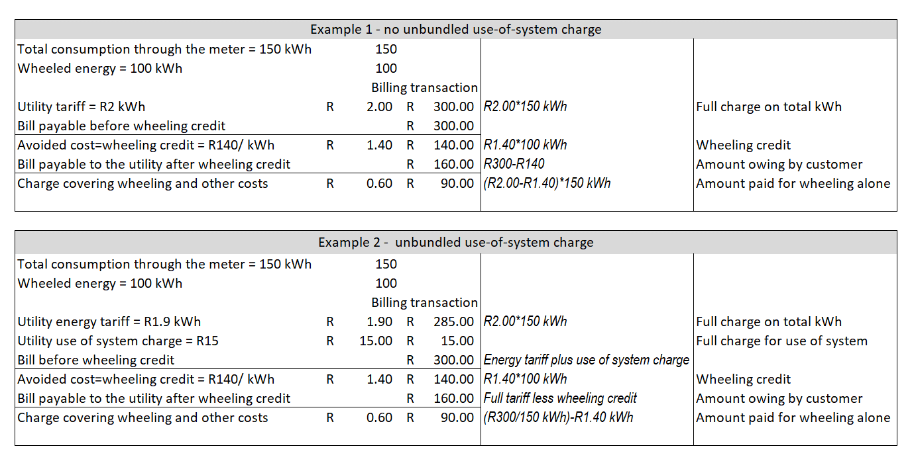Below further illustrates the two options:

Billing process and methodology:

* Two billing time periods used may be used, being the Total per Time-of-Use (TOU) period and per 30-minute interval.
* Eskom follows the TOU methodology; customers/generators not on TOU tariffs may need to change in the future. TOU tariffs are designed to encourage customers to use electricity during off-peak hours when demand is lower, which helps to balance the load on the grid and can lead to cost savings. As the market matures and trading develops, more customers/generators may transition to TOU tariffs.
* The Municipality's Wheeling Approach may need to be similar to Eskom's methodology. Following a similar approach to Eskom's methodology ensures consistency and compatibility between the Municipality's and Eskom's wheeling processes, making it easier for customers and generators to transition between the two systems.
* The Off-taker's account is credited with received wheeled energy value, adjusted for losses using wholesale energy pricing structure (WEPS). Crediting the off-taker's account for wheeled energy, and considering losses, ensures fair compensation for both the customer and the generator based on actual energy received and consumed.
* For Eskom-connected generators, credits pass through Municipal account to Off-taker's account. This ensures a smooth flow of funds and accurate accounting for energy transactions between the generator, Eskom, and the Municipality.
* For Municipal-connected generators, the Municipality generates wheeling credits based on energy metered at the Generator's supply point. Generating wheeling credits based on actual metered energy at the generator's supply point provides transparency and accuracy in accounting for energy transactions within the Municipality's grid.
* Data retrieval from smart meters at Generators (either Eskom or Municipal meters) or data retrieval from the generator's check meter is required. Smart meters provide real-time and accurate data on energy consumption and generation, facilitating efficient billing processes. Retrieving data from the generator's check meter provides backup data for billing accuracy.
* Eskom issues the Municipality an invoice for all consumption and fixed charged including credit for net exportable power enabling the Municipality to account for wheeled energy accurately and efficiently in its billing process.
* Customers provide net billing data; re-allocation based on actual generation and consumption can then be made. Net billing data from customers ensures accurate accounting for their energy consumption and generation, allowing for any adjustments needed based on actual usage.
* Energy allocation changes require the Generator to notify Eskom by the 3rd day of the calendar month. Timely notification of energy allocation changes allows for smooth billing adjustments and accurate accounting for energy transactions between Eskom, the generator, and the Municipality.
* Municipality issues valid tax invoices to customers, covering utility-sold energy and wheeled energy. Valid tax invoices provide customers with a clear breakdown of charges, ensuring transparency and compliance with tax regulations.
* Actual wheeled energy credited on customer invoices using actual kWh allocated to Off-taker's account multiplied by the wholesale energy pricing structure (WEPS) ensures fair billing for wheeled energy
* The effective use-of-system charge for wheeled energy is the full tariff charge minus the wholesale energy price. This creates a proper accounting for system costs and avoids overcharging or undercharging for wheeled energy.
* The Municipality reconciles the wheeling account monthly based on TOU basis, aligning with Eskom's approach, allowing for billing that is accurate and up to date, for efficient accounting and billing processes.
* Customers settle Municipality invoices, and the Municipality settles Eskom. Settling invoices promptly ensures smooth financial transactions between customers, the Municipality, and Eskom, avoiding delays or discrepancies in payment.

# Scenarios for Contracting, Metering & Billing

🔍 ***Explanatory notes:***

*The section on scenarios outlines different situations in which the implementation of wheeling may vary based on the generator's and off-taker’s connection. The Municipality play a critical role in identifying and understanding these scenarios to effectively facilitate the wheeling process. Some key actions that The Municipality need to undertake include:*

* ***Identify Wheeling Scenarios:*** *The Municipality should identify and categorize the specific wheeling scenarios relevant to their municipality. These scenarios may include different types of generator connections, such as a direct connection to the municipal grid or a connection through Eskom Networks, or a third-party network. Understanding the specific scenarios helps in tailoring the wheeling framework accordingly.*
* ***Assess Infrastructure Requirements:*** *The Municipality need to assess the infrastructure requirements where the generator is connected to the Municipalities distribution grid. This involves evaluating the capacity and capability of the existing grid infrastructure to accommodate the wheeling transactions and ensuring that the necessary technical provisions are in place for reliable and efficient electricity transfer.*
* ***Develop Guidelines and Processes:*** *The Municipality should develop clear guidelines and processes for each identified wheeling scenario. These guidelines should address the specific requirements, procedures, and considerations associated with each scenario. They should provide stakeholders with a step-by-step framework to follow for successful wheeling implementation.*
* ***Coordinate with Stakeholders:*** *The Municipality need to coordinate and collaborate with all relevant stakeholders involved in the specific wheeling scenarios. This includes generators, customers, traders, Eskom, and other regulatory bodies. Effective coordination ensures that all parties are aware of their roles and responsibilities and facilitates a smooth and transparent implementation process.*
* ***Monitor and Evaluate Performance:*** *The Municipality should monitor and evaluate the performance of the wheeling system in each scenario. This includes assessing the reliability, efficiency, and cost-effectiveness of the implemented processes. Regular monitoring and evaluation help identify any areas for improvement and ensure that the wheeling framework continues to meet the needs of all stakeholders.*

*By identifying wheeling scenarios, assessing infrastructure requirements, developing guidelines and processes, coordinating with stakeholders, and monitoring performance, The Municipality contribute to the successful implementation of the wheeling system in various scenarios. Their proactive involvement ensures that the wheeling process is tailored to the specific needs of their municipality, promoting efficient and sustainable electricity transfers.*

**💡Illustrative example**

The implementation of wheeling differs depending on where the generator and off-taker are connected. The scenarios will determine the agreements required, and the tariffs and billing to be applied.

As a starting point, the Municipality is facilitating the first two wheeling scenarios:

* **Scenario 1:** Eskom-connected generator wheeling to a Municipal off-taker.
* **Scenario 2:** Municipal-connected generator wheeling to within the same municipality to a Municipal off-taker.
* **Scenario 3:** Municipal-connected generator wheeling to Eskom-connected off-taker
* **Scenario 4:** Municipal-connected generator wheeling to a Municipal off-taker in another municipality. This scenario is included for completeness, notwithstanding that there is currently no mechanism contemplated for this. This reflects that there is a need for such a scenario and future work will be required to address this.
* **Scenario 5:** Eskom-connected generator wheeling to Eskom-connected off-taker (not applicable for this document)

There may be a trader involved where energy from one or more generators, is allocated to multiple off-takers.

In cases where multiple generators supply electricity to multiple end-users, complex energy transactions and arrangements between different parties can be facilitated by implementing the following key enablers:

* **Eskom virtual wheeling**: This refers to the accounting and financial arrangement where energy from a generator connected to the Eskom transmission network is virtually allocated and credited to an end-user without physical energy transfer. Refer to the Eskom Virtual wheeling guide <https://www.eskom.co.za/distribution/wp-content/uploads/2023/07/20230710_-9553-Virtual-Wheeling-Digital-Brochure-FINAL.pdf>
* **Energy traders, aggregators or retailers:** Acting as intermediaries, they purchase power from multiple generators and sell it to multiple end-users, or they purchase power from an Independent Power Producer (IPP) and sell it to an end-user.

Additionally, wheeling scenarios may involve agreements that allow for curtailment or demand response measures, where the amount of electricity wheeled may vary based on specific conditions or requirements. There can also be specific wheeling arrangements for special customer categories, such as mining or industrial customers with high power demands.

For illustrative purpose, figures were created to show the contractual agreements as well as the billing that will take place.

**The embedded document in section 3, Infographic on steps provides all the scenario images in editable format**

**Scenario 1a: Eskom-connected generator wheeling to a Municipal off-taker.**

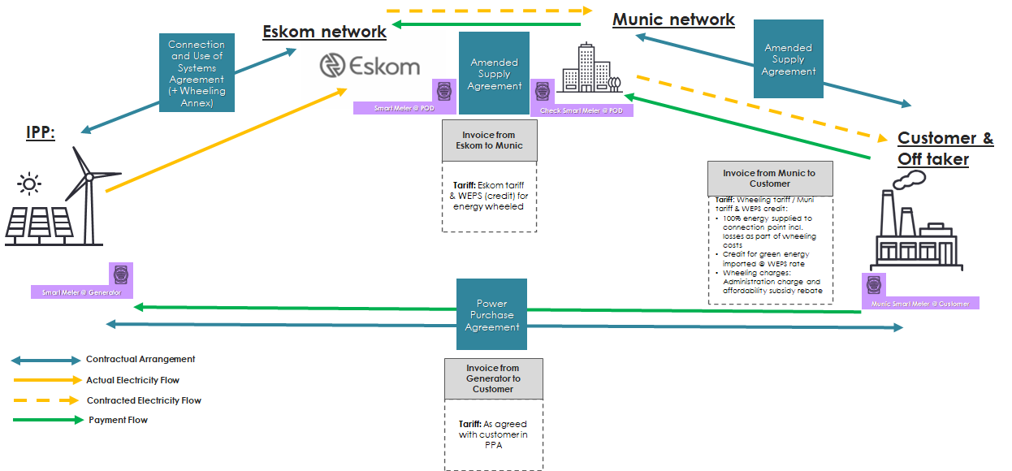

In this wheeling scenario, the Generator is located outside the municipality's network, and the off-taker is situated within the municipality’s network. This scenario requires the generator to comply with the Eskom’s connection requirements and the generator must apply to Eskom for grid connection.

The following agreements will need to be put in place in this scenario:

* An amended supply agreement between Eskom and the Municipality to reflect that wheeling credits will be added to the bill.
* An amended electricity supply agreement between the Municipality and the Off-taker to reflect that wheeling credits will be added to the bill.
* A Power Purchase Agreement (PPA) between the Generator or Trader (see section below) and the Off-taker.
* A use-of-system agreement between the Generator and Eskom to reflect the allocation of the total energy exported to the grid to be credited to the Off-taker.
* If a trader is used, the following additional agreements are required:
* Generator PPA: Between the Generator and Trader, including term and pricing
* Customer PPA: Between the Trader and the off-taker, including term and pricing
* If wheeling is done in a municipality, a Municipal Use of Systems Agreement (UoSA) must be signed between the trader and the Municipality

Implementing wheeling from Eskom-connected generators has a range of benefits which include:

* Generators can be located in areas with highest renewable energy resource.
* Eskom’s transmission network has capacity for much larger generators than the Municipal network.
* Eskom has far more experience than the Municipality with connecting larger than one megawatt generators to the grid including grid code compliance.
* Eskom already has a wheeling framework in place which passes the generator’s wheeling credits onto the municipal account.

While the Municipality is doing what it can to facilitate wheeling from Eskom-connected generators, a major challenge that remains in the way of implementation is the Eskom security deposit required for third party wheeling. Funding the updated security deposits may prove difficult for the Municipality to fund, but work is being done by National Government to support municipalities fund these security deposits; nonetheless, these deposits remain a challenge to implementing wheeling from Eskom-connected generators. Municipalities have also been made aware of Eskom’s work on a Virtual Wheeling Platform with the intention is that this model will overcome the security deposit issue.

**Electricity Trading**

Electricity Trading is the delivery of electricity generated by multiple private operators in many locations to multiple buyers or off-takers in different locations, via a third-party network. It allows for the aggregation of energy supply from various private generation projects, and the consolidation of different forms of renewable power available in the energy mix (allocation optimisation). As South Africa moves into a future of competitive electricity supply, the landscape simultaneously becomes more complex as well as more efficient - where demand is met by dynamic trade. *The Trader will play a critical role in addressing the energy crisis, determining the net impact of this market reform, and driving transformational change over time.*

**Scenario 1b with an Energy Trader is depicted below:**

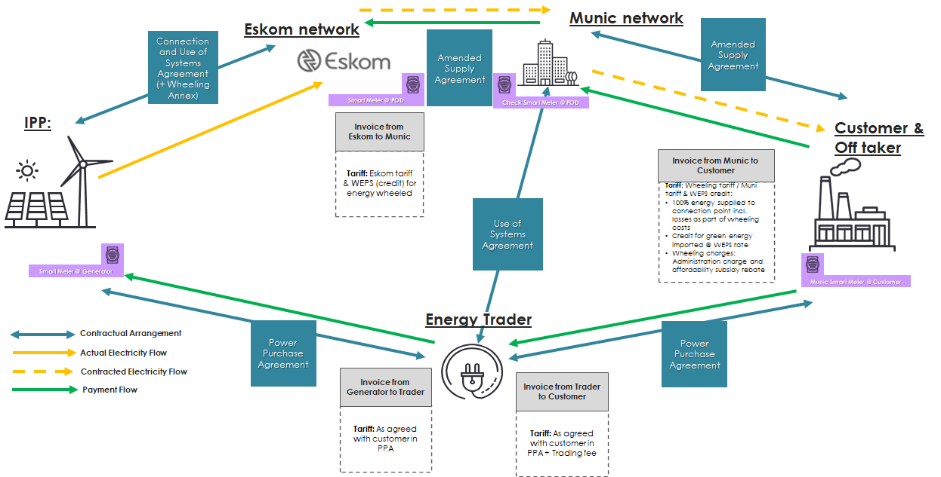

**Scenario 2a: Municipal-connected generator wheeling to a Municipal off-taker.**

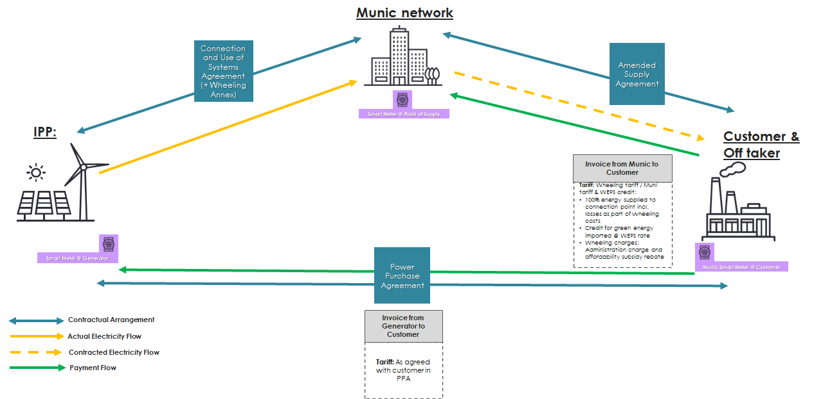

In this wheeling scenario, the Generator is located within the municipality's network, and the off-taker is also situated within the municipality's network. This scenario requires the Municipality to process the Generator’s connection application as it will be connected to the Municipality’s grid.

The following agreements will need to be put in place in this scenario:

* The Generator has a Connection and Use-of-System agreement with the municipality.
* The Off-taker signs an amended/addendum electricity supply agreement with the Municipality.
* A PPA between the Generator or Trader and the Off-taker.

There are a range of benefits to wheeling from a local generator connected to the Municipal network. These include:

* Reduced wheeling transaction costs as the generator avoids paying Eskom Use-of-System (UoS) charges.
* Reduced electrical losses as the electricity does not flow across the transmission grid.
* Building power plants in the Municipality stimulates the economy and creates jobs.
* Local generation reduces the Municipality’s reliance on Eskom.

The Municipality is working to facilitate this wheeling scenario. However, connecting large generators to the distribution grid remains challenging for the Municipality. The Municipality’s billing system also requires updating to facilitate the reconciliation of wheeled energy between the Generator and the Off-taker.

**Scenario 2b with an Energy Trader is depicted below**

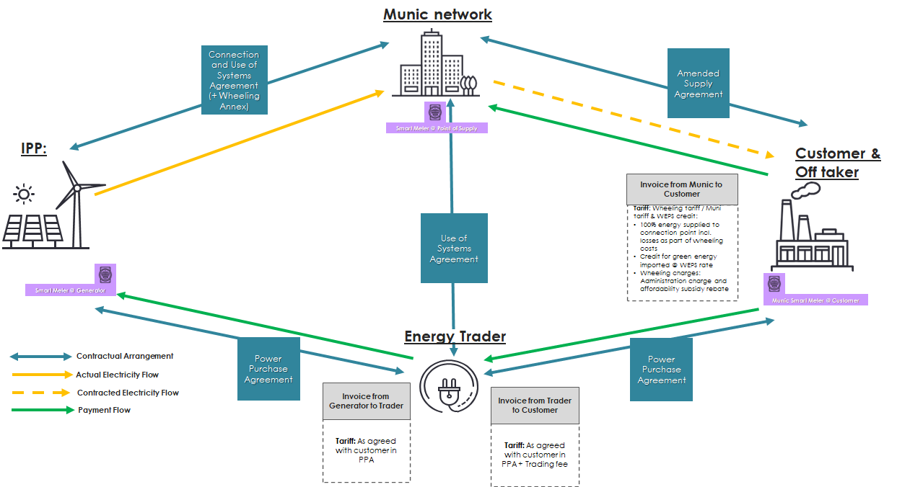

**Scenario 3: Municipal-connected generator wheeling to Eskom-connected off-taker**

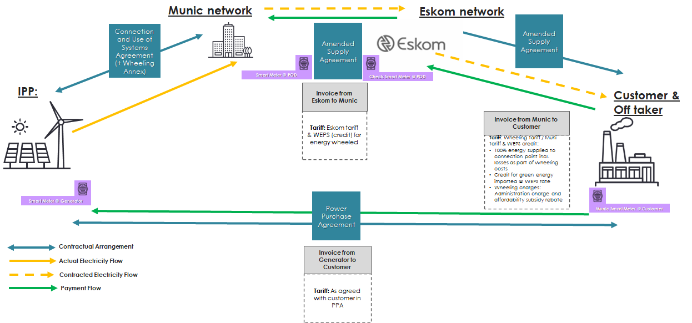

In this wheeling scenario, the generator is connected to the municipality's grid, and the off-taker is connected to Eskom's grid. The energy generated by the municipal-connected generator is wheeled to the off-taker who is supplied by Eskom.

To facilitate this wheeling arrangement, the following steps and agreements may be involved:

* Agreement between the Municipality and Eskom: The Municipality and Eskom need to establish a wheeling agreement that outlines the terms and conditions of the energy transfer from the municipal-connected generator to the Eskom-connected off-taker.
* Use-of-System Agreement (UoSA): The Municipality, as the host network, would need to have a UoSA in place with Eskom to allow for the wheeling of energy from the municipal-connected generator to the Eskom-connected off-taker.
* Agreement between the Generator and Municipality: The generator, being connected to the municipal grid, should have an agreement with the Municipality that covers the connection and use of the distribution system for wheeling purposes.
* Agreement between the Off-taker and Eskom: The off-taker, being supplied by Eskom, should have an agreement with Eskom for the provision of electricity through the wheeling arrangement.
* Billing and Energy Accounting: The Municipality needs to have a system in place to accurately measure the energy generated by the municipal-connected generator and the energy consumed by the Eskom-connected off-taker. The billing process should reflect the amount of wheeled energy transferred from the generator to the off-taker.
* Compensation Mechanism: The compensation mechanism for this wheeling scenario would involve the Municipality crediting the Eskom-connected account.

It is important to note that implementing this wheeling scenario may involve coordination and cooperation between the Municipality and Eskom, as well as adherence to regulatory requirements and technical specifications for seamless energy transfer between the two networks. Proper monitoring and reporting mechanisms may also be necessary to ensure transparency and compliance with the wheeling arrangement.

# Qualifying Criteria

🔍 ***Explanatory notes:***

*In the context of Qualifying Criteria for wheeling energy, The Municipality are responsible for establishing and defining the criteria that need to be met in order to qualify for wheeling. The criteria should align with the Energy Regulation Act (ERA), third-party wheeling rules (when published), and any other relevant regulations. Here is a summary of the key points and actions for The Municipality:*

* ***Determine Eligible Consumers:*** *The Municipality need to identify the specific consumer categories eligible for wheeling. This may include consumers on specific tariffs, connected at a minimum voltage level, and with a notified maximum demand (NMD) above a certain threshold.*
* ***Tariff Considerations:*** *The Municipality should outline the tariff rules applicable to consumers qualifying for wheeling. This includes the Network Access Charge (NAC) and the duration of the wheeling agreement. The tariff structure should ensure that consumers continue to qualify for wheeling even if their NMD decreases below the initial threshold.*
* ***Written Wheeling Agreement:*** *The Municipality must ensure that the Municipality and the consumer enter into a written wheeling agreement or amend existing consumer/supply agreements to include wheeling provisions. This agreement, along with Municipality by-laws, policies, and tariffs, should establish the terms and conditions for accounting and billing of wheeled energy.*
* ***Compliance with Regulations:*** *The Municipality need to ensure that the qualifying criteria and wheeling agreements comply with all relevant regulations, including the ERA, third-party wheeling rules (when published), and any applicable grid code requirements. This ensures that the wheeling process is legally and technically compliant. Considerations could also include environmental impacts and compliance to environmental regulations such as the National Environmental Management Act (NEMA).*
* ***Generation Connection Agreement:*** *If the generator is connecting to the Municipality’s distribution network, The Municipality should require the generator to enter into a generation connection agreement with the Municipality. This agreement ensures that the generator meets all technical, legal, and contractual requirements before injecting energy into the system.*
* ***Use-of-System Agreement:*** *The Municipality should require the generator or energy trader to enter into a wheeling (use-of-system) agreement with the Municipality and, if necessary, with Eskom. These agreements establish the terms and conditions for the wheeling process, including the charges, metering, and other relevant aspects.*
* ***Metering and Measurement:*** *The Municipality are responsible for advising generators and customers on requirements for installing and maintaining metering equipment to measure the electricity at each metering point, such as the generation and consumer points. This ensures accurate measurement and accounting of wheeled energy. The Municipality must ensure continuous metering installation integrity.*
* ***Network Capacity Considerations:*** *The Municipality must assess the network capacity of the Municipality’s grid and, if applicable, Eskom's grid to ensure that the wheeling agreements do not exceed the network's capacity. This evaluation helps avoid any adverse impact on the reliability and stability of the electricity supply.*
* ***Generator Quality of Supply Considerations:*** *The Municipality must assess the quality of supply of the Municipality’s grid and, if applicable, Eskom's grid to ensure that the parties to the wheeling agreement (specially the generator) do not negatively affect the quality of power supply. This evaluation helps avoid any adverse impact on the quality, reliability, and stability of the electricity supply. Consideration could be around establishing a baseload, and continuous monitoring of Quality of Supply.*
* ***Operation of Other Wheeling Agreements:*** *The Municipality must assess any existing wheeling agreements where the applicant and generator might be involved. Considerations must be around other municipalities, length of agreements, and any potential penalties or sanctions raised against the applicant in other Municipalities.*

*By establishing clear and comprehensive qualifying criteria, The Municipality enable a transparent and consistent process for wheeling energy. They ensure compliance with regulations, protect the integrity of the distribution network, and facilitate efficient and effective wheeling operations.*

**💡Illustrative example**

Please refer to Appendix B of illustrative examples of qualifying criteria from Municipalities

For wheeling electricity from within, or to, the municipal electricity distribution network, the following needs to be considered by the Municipality:

* Safety

Safety and security in the electrical environment are of the utmost importance. There is no tolerance for any deviation from regulatory requirements. Consideration needs to be given to which Statutory Requirements, other than the OHS Act, need to be complied with.

* Compliance to the Occupational Health and Safety Act, No. 85 of 1993.
* Security

The Municipality needs to consider which policies and protocols needs to be developed or updated regarding:

* Emergency response and coordination to protect the integrity of the distribution network.
* Cybersecurity measures and data exchange policies and protocols need to be established.
* Legal and Regulatory

The municipality must ensure that all relevant South African Statutory Requirements are adhered to. To this extent, the generator must meet all the SA Grid Code requirements before injecting energy into the South African power system, including technical, legal and contractual requirements. The following Statutory Requirements are applicable:

* Electricity Pricing Policy (EPP)
* Electricity Regulation Act (ERA)
* National Energy Regulator Act (NERSA Act)
* Local Government (Municipal Systems) Act (Systems Act)
* Municipal Fiscal Powers and Functions Act (MFPFA)
* Municipal bylaws and policies: The municipality may need to develop or update its municipal bylaws and policies to accommodate the wheeling of electricity. These bylaws should align with the national regulations and support the implementation of wheeling arrangements.
* National Third Party Wheeling Framework (when approved).
* Tariff Construction

The municipality should establish transparent and fair wheeling charges and tariffs in line with NERSA's guidelines. The tariffs should consider factors such as the cost of network use, infrastructure maintenance, and administrative expenses, while promoting efficiency and competitiveness in the electricity market.

* Guiding and approval of tariffs by NERSA
* Municipal tariff design
* NERSA cost of supply framework
* NRS 058 (Draft)
* Tariff Application

The Municipality needs to consider the following:

* Any changes to the applied tariff of the off-taker after the onset of the wheeling agreement must be effected.
* The tariff will be revenue neutral for the municipality (i.e. the municipality will not lose any revenue through wheeling). Any additional charges for wheeling added by Eskom to the municipality’s account will be for the off-takers account.
* Infrastructure

The municipality needs to consider the generator connection allowances with due consideration of the characteristics of the existing electricity reticulation network as follows:

* Voltage levels at Point of Utility Coupling for both the off-taker and the generator. It is to be considered that the voltage at PUC be the same as that of the Municipal voltage level e.g., 6.6kV.
* Minimum required Notified Maximum Demand (NMD) of the off-taker. It is to be considered that the NMD of the off-taker be no less than the Municipal requirements e.g., 1MVA.
* Considerations around building plan approvals.
* Technical Feasibility
* The municipality should assess the capacity and condition of its distribution network and plan for any necessary upgrades or expansions. This may involve coordinating with the relevant generator and considering future load projections and growth scenarios.
* No wheeling agreement will be entered into with a consumer, or connection and use-of-system agreement with the generator and energy trader, if the network capacity of the Municipality’s grid (supply mains/distribution and/or reticulation network) and/or Eskom grid will be exceeded as a result thereof.
* A grid impact study needs to be performed at the Generator’s cost and signed off by an independent Registered Professional Engineer. Results to be submitted to the municipality for evaluation.
* Before connecting to the municipal grid, the generator needs to do a Quality of Supply study (at the busbar where the connection will be made) to determine the base case.
* Contractual Agreements

Depending on the Wheeling scenario, consider which of the following agreements need to be in place:

* Supply Contracts
* Power Purchase Agreement between the Generator//Off-taker
* Connection/Use-of-System Agreement with Municipality, with wheeling annexure.
* Supplemental Electricity Supply Agreement
  + This agreement reflects delivery of private power to the Off-taker by the Municipality from the Generator.
  + The agreement accounts for the payment of the necessary tariffs and administration fees to the Municipality.
* NERSA: Generator to enter into a wheeling agreement with Municipality.
* Wheeling agreement with Eskom to accommodate wheeling from a generator outside the Municipality.
* Environmental Impacts

The Municipality should consider which environmental regulations must be adhered to:

* The National Environmental Management Act (NEMA), No. 107 of 1998
* NEMA Regulations
* Water Use License (WULA)
* Environmental Impact Assessment (EIA)
* Waste License
* SALA
* Financial and Creditworthiness

The Municipality must consider assessing the financial stability and creditworthiness of the role-players. This evaluation helps to:

* Determine the role-player’s ability to fulfil its financial obligations, such as paying wheeling charges, maintaining infrastructure, and meeting any other financial commitments.
* Measurement of consumed energy

Considerations need to be given to:

* Points where electrical energy will be measured, typically the Generator and Consumer.
* The Municipality shall provide, install and maintain four quadrant metering equipment configured to record import and export power, at the cost of the consumer, to measure the electricity at each metering point.
* The generator to install a permanent Quality of Supply (QOS) recorder on the busbar for continuous monitoring of the QOS parameters
* Frequency of reconciliation of measured data
* How differences from different meters would be dealt with
* Energy will be wheeled excluding green benefits and the Municipality will not be responsible for the verification or certification of green benefits.
* Any electrical energy not consumed by the off-taker will not be credited, i.e. no banking of energy will be allowed and no compensation will be paid by the Municipality to the generator.
* Company registration requirements
* Company registration certificate/ copy of identity document
* Shareholder structure
* It is a consideration whether applicants will have to demonstrate some level of Broad-Based Black Economic Empowerment.
* General Considerations
* All costs applicable to the connection of the generator to the grid will be for the generators account.
* Other utilities
* Being up to date on payments for water, sewer, refuse and rates.

# Application Process

🔍 **Explanatory notes:**

*The Municipality is responsible for facilitating the application process for wheeling electricity. They ensure the availability of the application form, assist applicants in completing it, and coordinate with other municipal departments for necessary approvals. The official reviews completed applications, assesses them based on predetermined criteria, and provides written notification of the outcome. They may conduct inspections if required and monitor compliance with technical standards and regulations. Once approved, the official facilitates the connection to the municipal electrical network, including meter installation and tariff changes. They enforce compliance with billing procedures, insurance requirements, and permits throughout the operation of the wheeling arrangement.*

*Below please find an embedded application template that can be adapted by the Municipality.*

**

**💡Illustrative example:**

Wheeling applications will be handled on a case-by-case basis, and grid studies may need to be completed.

Contact: <mailto:contact@municipality.gov.za>

Below is the recommended process:

The *Application to Wheel Energy* *form* shall be completed for all applications to wheel energy in the municipal electrical network. The forms are available on the Municipality's website or from the electricity department offices.

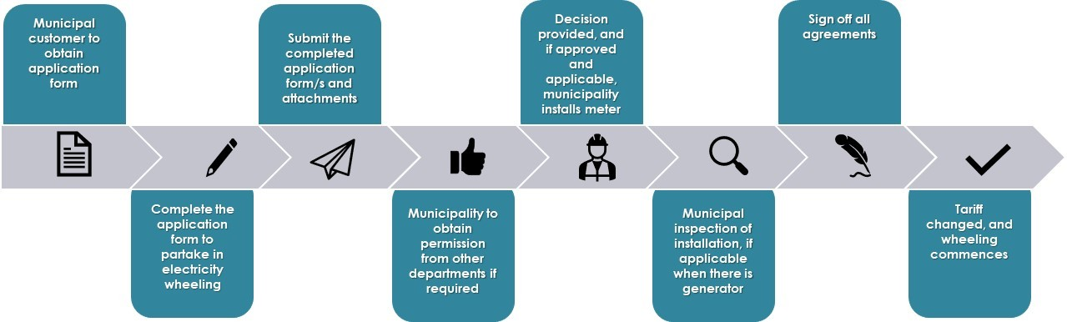

**Step 1: Municipal customer to obtain Application Form**

* Visit the Municipality's website and download the relevant application form/s or request the forms from the electricity department offices.
* The application form may require details such as the proposed capacity of the generator, the proposed location of the generator, and the estimated annual energy output.
* The applicant may need to provide a single-line diagram of the proposed installation, showing how it will be connected to the municipal grid.
* This form should be filled in by the IPP, trader (if applicable) and off taker/customer of the municipality whose name the property is registered under and whose name the electricity account is in (i.e., Municipal Account Holder), who intends on engaging in a third-party wheeling transaction.
* This form must then be submitted by the off taker/customer.

**Step 2: Complete the application form to partake in electricity wheeling**

* The Municipality requires the current electricity customer/account holder to sign the application form/s.
* Details of the proposed generator shall also be provided.
* The customer may need support from the generator or registered personnel in completing the application form.

**Step 3: Submit the completed application form/s and attachments**

* Form/s shall be submitted to the relevant contacts at the electricity department.
* An offtake agreement/Power Purchase Agreement between the generator or trader and the customer needs to be included with the application form.
* If the generator is connected outside the municipal area of supply, the Use-of-System Agreement with the other authority needs to be supplied.

**Step 4: Municipality to obtain permission from other departments as required (applicable when generator is within Municipality)**

* The electricity department requires prior approval of the proposed wheeling arrangement from other departments as stipulated in the form (e.g., buildings department). All such approvals must be reflected in or submitted with the application form.
* The applicant may need to obtain approval from other relevant regulatory bodies, such as the NERSA or the Independent Power Producer (IPP) Office.
* In future, the applicant may need to obtain approval from the local distribution network operator (DNO) or the national transmission system operator (TSO) if the installation is connected to the transmission grid.

**Step 5: Decision provided, and if approved and applicable, municipality installs meter**

* After consideration of the application, the customer will be informed in writing whether the application has succeeded, together with any operational and other requirements deemed necessary. If the application is declined, reasons should be provided. If the municipality requires further information or grid studies, the customer will be notified thereof.
* Once notified of a successful application, the Municipality may commence installation (it is advised that the customer does not pay for any equipment until municipal approval is granted in writing, as such approval is not guaranteed).
* The municipality may require the customer to pay a fee for processing the application.

**Step 6: Municipal inspection of installation, if applicable when there is generator**

* The Municipality shall inspect the installation if was not performed by the municipality and they deem it necessary.
* The municipality may require the customer to provide ongoing reports on the performance and safety of the installation, including regular maintenance and testing.
* The municipality may require the customer to comply with specific technical standards or guidelines, such as those set by NERSA or the South African Bureau of Standards (SABS).

**Step 7: Sign off all agreements**

* After the application has been approved, the necessary agreements need to be signed by all parties involved.
* This step formalizes the commitment to the wheeling arrangement and outlines the rights and responsibilities of each party.
* Details of agreements are included in section 8.

**Step 8:**  **Tariff changed, and wheeling commences**

* The addition/change of the wheeling tariff shall be implemented.
* The municipality may require the customer to provide ongoing reports on the energy usage of the installation, for billing and monitoring purposes.
* The municipality may require the customer to comply with specific billing and invoicing procedures, such as submitting regular meter readings or using a specific billing system.
* The municipality may require the customer to comply with specific legal and regulatory requirements, such as obtaining insurance or permits for the installation.

# Generator Connection Process

*🔍* ***Explanatory notes:***

*The generator connection process involves submitting an application to the Municipality, obtaining approval, installing the generator according to regulations, conducting inspections if necessary, connecting to the municipal network, and providing ongoing reports on performance. The Municipality oversees the process, ensuring compliance and adherence to standards.*

**💡Illustrative example**

* Generators applying to connect to Eskom’s grid will need to follow Eskom’s grid connection process. Generator’s applying to connect to the Municipal grid will be assessed in line with the existing Embedded Generation Policy.
* The Municipality has developed Requirements for Embedded Generator (EG) to connect to the Municipal Network. These remain applicable in the case of generators connecting to wheel electricity.
* According to the latest Schedule 2 of the ERA (First released on 15 December 2022 with a re-release on 17 January 2023 with a minor correction. Available here: [Electricity Regulation Act: Amendment: Licensing Exemption and Registration Notice. Govt Gazette No 47877, 17 January 2023](https://www.sseg.org.za/era-schedule-2-embedded-generation-license-exemption-15dec2022/)) Thefollowing registration and licensing exemptions exist for Embedded Generation connected to the Municipal Network:
* Exempt from NERSA registration and licensing:
  + EG of any size which are primarily for self-consumption (not for wheeling/export)
  + EG for wheeling/export up to 100kW
* Require NERSA registration but exempt from licensing:
  + EG for wheeling/export over 100kW
* As such, generators over 100kW that are built for the purpose of wheeling require NERSA registration and must comply with the Code.
* More information on NERSA’s registration process as well as the broader process the Municipality will follow when connecting larger than 1 MW generators to the Distribution grid can be found in the Guide for Assessing Embedded Generation 1MW and Larger (The > 1 MW Guide is available online: <https://www.sseg.org.za/guide-for-municipalities-on-assessing-eg-applications-1mw-and-larger/>)

# Payments Due

*🔍***Explanatory notes:**

The payments due by the customer and potential trader may vary. The customer is responsible for paying the wheeling charges and energy consumption fees as per the Municipality's billing procedures. The potential trader, on the other hand, is required to fulfil financial obligations such as processing fees, use-of-system charges, and any other agreed-upon payments outlined in the wheeling agreement. Additionally, the generator may also be responsible for paying certain fees and charges, including connection fees, metering charges, and other costs related to the installation and operation of the generator. It is the Municipality's role to ensure that all parties involved understand and meet their respective payment obligations within the third-party wheeling transaction.

**💡Illustrative example**

The generator may be responsible for paying for the following:

* Connection charges: If applicable, these are fees charged by the network operator to connect the generator to the network. The fees may vary depending on the size of the connection, the type of equipment required, and other factors.
* Specialist municipal electrical network impact studies: If required, the generator may have to pay for these studies. The details of payment amounts for such studies need to be discussed with the municipality.
* Changes required to the municipal electrical network: If any changes are required to the municipal electrical network upstream of the connection point due to the wheeling arrangement, the generator will have to bear the cost.
* Specialist tests: The generator will have to pay for any specialist tests that are required, such as inverter testing.
* Any other associated costs: The supply and installation of meters (under the Municipality's metering policy)

**Payments Due by the Off Taker/Customer:**

* Electricity Usage – PPA vs Municipality: This pertains to the cost of the electricity consumed by the customer through the wheeling arrangement. It's crucial to differentiate between the costs agreed upon in the Power Purchase Agreement (PPA) with the generator and the charges set by the municipality for distribution and other services.
* Admin Charges: These might encompass administrative fees levied by the municipality for managing the billing, administrative processes, and overall operation of the wheeling arrangement.
* Access Fees: These charges are imposed by the network operator to grant the customer access to the electrical network. The fees can be calculated based on factors like energy consumption or capacity used, with potential variations based on time of day and location. These charges are usually in line with the municipality's tariff bylaws.
* Transmission Charges: These fees are imposed by the transmission company for transporting energy from the generator's location to the customer's premises. The charges can be influenced by factors like distance traveled, energy type, and network demand.
* Trading Charges: If the customer collaborates with a trader to manage energy transactions, there may be costs linked to trading activities. These charges could encompass fees for operating the trading platform, transaction processing, and other relevant services.

**Payments Due by the Potential Trader:**

* Admin Charges: These are administrative fees, that could be imposed by the municipality or involved parties, to cover the operational aspects of managing the energy trading activities.
* Trading Charges: If the customer engages a trader to handle energy trading, the trader might levy charges associated with using their trading platform and facilitating energy transactions. These charges can encompass platform management fees, transaction processing fees, and other relevant costs.

In essence, these payment structures and responsibilities help outline the financial aspects of the wheeling arrangement. They ensure that all parties involved understand their obligations and contributions, contributing to the transparent and effective operation of the wheeling process. The specifics of these payments can vary based on agreements, regulations, and the unique context of the arrangement.

# Energy Supply and Demand Balancing

*🔍***Explanatory notes:**

The Municipality's role in energy balancing involves implementing and enforcing balancing rules once they are developed by the System/Market Operator and approved by NERSA. This includes ensuring compliance with the rules by generators, loads, and licensees, including those involved in third-party wheeling transactions. The Municipality will oversee the provision of hourly day-ahead forecasts and monitor deviations from these forecasts, which may result in balancing charges. Reconciliations for wheeled energy will be based on schedules rather than meter data

**💡Illustrative example**

Generators and loads, including Licensees, will in future be subject to grid supply balancing rules once such a mechanism is developed by the System/Market Operator and approved by NERSA. Balancing will take care of the difference between scheduled generation and actual generation.

It is envisaged that this would require hourly day-ahead forecasts to be provided, and on which balancing charges may be raised for deviation from the forecast for all balance responsible parties including those in third-party wheeling transaction. Reconciliations for Wheeled Energy will then be done on schedules and not the meter data.

Balancing is a system operator function. Settlements for balancing will in future when balancing is introduced be done hourly, but reconciliation can still be done monthly on the schedules. The shortfall will be for the account of the balancing party, that is wheeled energy is forecasted, scheduled and assumed delivered and reconciled on the forecast. If there is a deviation from the forecast, the balance responsible party will cover this cost.

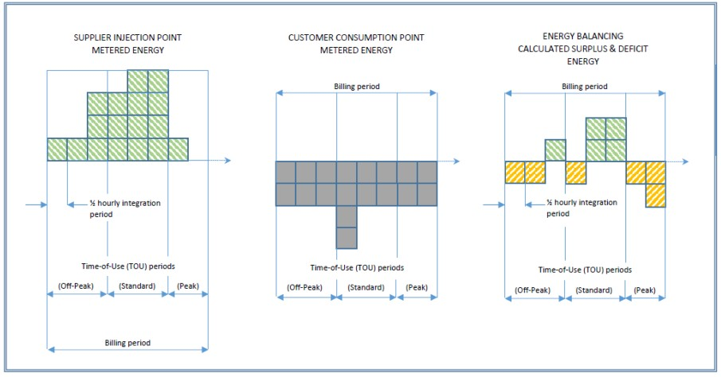Energy is accounted for in near-real time over each ½ hourly metering integration period and energy balancing will be done over the same period. In an established market environment, surplus energy would be cheap, while deficit energy would be expensive, with these prices passed onto customers willing to take or forgo this energy to achieve energy balancing. Until the market environment matures, the municipality will supply deficit energy at regulated tariffs, while surplus energy will be taken at zero price unless the customer has instituted greening. In line with the current regulatory environment, these transactions will be done directly with the customers and potentially energy traders

# Dispute Resolution Process

🔍**Explanatory notes**

*The Municipality's role in the dispute resolution process involves receiving and assessing formal complaints, mediating between parties to find a resolution, making fair decisions if necessary, documenting the process, communicating the resolution to all parties, and ensuring compliance with the agreed-upon terms. Their responsibilities include conducting thorough investigations, facilitating negotiations, maintaining clear communication, and monitoring compliance to resolve disputes in a fair and transparent manner. Detailed guidelines on the process must be developed for resolving disputes between stakeholders, including escalation procedures.*

**💡Illustrative example**

Dispute resolution process and the responsibilities of the Municipality:

* Initiation of dispute resolution process:
  + When a dispute arises between parties involved in the third-party wheeling transaction, one of the parties initiates the dispute resolution process by submitting a formal complaint or request for resolution to the Municipality to [contact@municipality.gov.za](mailto:contact@municipality.gov.za)
  + The Municipality receives and acknowledges the complaint, ensuring that all necessary information and supporting documents are provided.
* Investigation and assessment:
  + The Municipality thoroughly examines the complaint and gathers relevant information from all parties involved.
  + They assess the nature and scope of the dispute, ensuring compliance with relevant regulations and contractual agreements.
  + The Municipality may engage in discussions with the parties to understand their perspectives and gather additional information if needed.
* Mediation and negotiation:
  + The Municipality acts as a mediator between the parties, facilitating negotiations and discussions to reach a mutually acceptable resolution.
  + They encourage open communication, clarify misunderstandings, and explore potential solutions that satisfy the interests of all parties involved.
  + The Municipality may propose alternative dispute resolution methods, such as mediation or arbitration, to help resolve the dispute amicably.
  + Mediation will also align to national rules for third party wheeling.
* Decision-making and resolution:
  + If the parties are unable to reach a voluntary resolution through mediation, the Municipality may be required to make a decision based on the evidence and information gathered.
  + They evaluate the arguments, contractual obligations, and relevant regulations to make an impartial and fair decision.
  + The decision may include directives, recommendations, or actions to be taken by the parties to resolve the dispute.
* Communication and documentation:
  + Throughout the dispute resolution process, the Municipality maintains clear and transparent communication with all parties involved.
  + They document the entire process, including the complaint, investigations, discussions, and final decision, ensuring that all information is accurately recorded and accessible for future reference.
  + The official communicates the resolution or decision to the parties involved, providing clear instructions on any necessary actions or compliance requirements.
* Follow-up and compliance:
  + The Municipality monitors the implementation of the resolution or decision and ensures that all parties involved comply with the agreed-upon terms.
  + They may conduct periodic reviews or inspections to verify compliance and address any non-compliance issues promptly.
  + The official maintains ongoing communication with the parties to address any concerns or questions related to the resolution or decision.
  + It is essential for the Municipality to be impartial, knowledgeable about relevant regulations and contractual agreements, and possess strong communication and negotiation skills to effectively manage the dispute resolution process.

# Tools, References and Further Information

The following resources may be useful for prospective parties interested in wheeling electricity:

* **Wheeling video:** This video gives a simple overview of what electricity wheeling is, the benefits of wheeling, and how municipalities can facilitate wheeling to their customers.

Link: [(27) Electricity Wheeling in South African Municipalities - YouTube](https://www.youtube.com/watch?v=n-qdiMX-DkE)

* **Wheeling Revenue Impact Model:** The Western Cape Government in partnership with Sustainable Energy Africa have developed a spreadsheet model that calculates the impact of wheeling on municipal revenue. The model is available at

Link: [Wheeling Revenue Impact Excel Model - Embedded Generation Resource Portal (sseg.org.za)](https://www.sseg.org.za/wheeling-revenue-impact-excel-model/)

* **Template - Municipal Wheeling Guideline**: A more summarized template guideline has been developed and is freely available.

Link: [Template Municipal Wheeling Guideline - Embedded Generation Resource Portal (sseg.org.za)](https://www.sseg.org.za/template-municipal-wheeling-guideline/)

* **Wheeling agreements:** The Western Cape Government in partnership with Pegasys has developed a set of template wheeling agreements (along with a user guide) which municipalities can customize according to their needs. The templates include a UOSs agreement, a connection agreement, and an amended electricity supply agreement. When released, they will found at this

Link: [Wheeling | 110% Green (westerncape.gov.za)](https://www.westerncape.gov.za/110green/energy/wheeling)

* **This Wheeling in South African Municipalities Report:** forms part of the Municipal Embedded Generation Support Program and is a collaborative effort by the South African Local Government Association (SALGA), Sustainable Energy Africa (SEA), the Western Cape Government, GIZ, GreenCape, Eskom and the AMEU.

Link: [SALGA Status of Wheeling Report 2023 - Embedded Generation Resource Portal (sseg.org.za)](https://www.sseg.org.za/salga-status-of-wheeling-report-2023/)

* **Eskom Wheeling Model:** Eskom has developed a model to assist generators and offtakes to understand the charges payable under a wheeling transaction as well as assist to analyse the benefits that the offtaker will receive.

Link: [Wheeling - Distribution (eskom.co.za)](https://www.eskom.co.za/distribution/tariffs-and-charges/wheeling/#Wheeling-tariff)

* **Eskom virtual wheeling**: This refers to the accounting and financial arrangement where energy from a generator connected to the Eskom transmission network is virtually allocated and credited to an end-user without physical energy transfer. Refer to the Eskom Virtual wheeling guide

Link: <https://www.eskom.co.za/distribution/wp-content/uploads/2023/07/20230710_-9553-Virtual-Wheeling-Digital-Brochure-FINAL.pdf>

* **Guide for Municipalities on Assessing EG Applications 1MW and Larger:** This guide provides a step-by-step overview of what municipalities must do to connect larger than 1MW generators to their distribution grids, including regulatory aspects, technical standards, and necessary documentation, etc. This is a useful guide for third-party energy providers that are interested in building embedded generators to wheel.

Link: <https://www.sseg.org.za/guide-for-municipalities-on-assessing-eg-applications-1mw-and-larger/>

* **Cost of supply practices:** Resources to support municipalities improve their electricity cost of supply practices.

Link: [Cost of Supply Studies - Embedded Generation Resource Portal (sseg.org.za)](https://www.sseg.org.za/cos/).

* **The cost of supply framework 2016 (NERSA):** is a document that provides guidelines for licensed electricity distributors to conduct cost of supply studies. It was issued by the National Energy Regulator of South Africa (NERSA) in March 2015.

Link: [Published-Consultation-Paper-COS-Framework-Final-1.pdf (nersa.org.za)](https://www.nersa.org.za/wp-content/uploads/2021/01/Published-Consultation-Paper-COS-Framework-Final-1.pdf)

* **The EPP 2008 (DMRE)**: is a document that outlines the policy framework for electricity pricing in South Africa. It was published by the Department of Minerals and Energy in the Government Gazette on 19 December 2008.

Link: [1-31741 19-12 Min (energy.gov.za)](https://www.energy.gov.za/files/policies/Electricity%20Pricing%20Policy%2019Dec2008.pdf).

# Proposed IT Systems to Implement

*🔍***Explanatory notes:**

*To effectively implement third-party wheeling and open access transmission, the Municipality needs to undertake the following tasks:*

* *Implement an automated application tracking system: To streamline the process and ensure timely completion of wheeling applications, the Municipality can implement an automated tracking system. This system would enable the Municipality to monitor the progress of each application, track key milestones, and identify any bottlenecks or delays that need to be addressed promptly.*
* *Implement a document management system: To effectively manage the flow of contracts and approvals, the Municipality can adopt a document management system. This system would help track the movement of contracts through the approval process, provide visibility to all stakeholders, and ensure that everyone is informed of the status of each document.*
* *Implement Smart metering systems: The integration of smart metering systems is a key enabler for successful wheeling operations. Smart meters provide real-time or near-real-time data on energy consumption, making it possible to accurately measure, monitor, and bill for the energy exchanged through the wheeling process. These systems enhance transparency, accountability, and accuracy in energy transactions, benefiting both the Municipality and customers.*
* *Update billing system: In order to accommodate wheeling transactions, the Municipality needs to update its billing system. This update should include necessary modifications to accurately calculate, and process charges associated with third-party wheeling, such as wheeling charges, energy consumption fees, and any other relevant financial obligations. (Note a manual billing tool is available to use in the interim)*

*Implementing these systems and processes will enable the Municipality to effectively manage third-party wheeling and open access transmission, ensuring transparency, efficiency, and accurate billing for all parties involved.*

*When there is a high increase in volumes of Third-Party Wheeling Transactions in the Municipality, the Municipality may need to consider investigating greater flexibility and grid balancing at the distribution level, to help to improve the resilience, efficiency, and reliability of the South African power system. Scaling flexibility services refers to the process of increasing the availability and use of services that help to balance the electricity grid in real-time. This is becoming increasingly important as the share of variable renewable energy sources, such as wind and solar power, in the electricity mix continues to grow. Flexibility services include a range of technologies and practices that can help to manage the variability of renewable energy generation and ensure a stable and reliable supply of electricity. For example, demand response programs allow consumers to adjust their energy use in response to grid conditions, while energy storage systems can store excess energy during times of high generation and release it back to the grid during times of high demand. Other flexibility services include virtual power plants, which aggregate distributed energy resources to provide grid services, and advanced forecasting and scheduling tools, which can help to optimize the use of renewable energy resources and reduce curtailment.*

*Scaling flexibility services requires a coordinated effort from municipalities, grid operators, regulators, and market participants to create a market environment that values and incentivizes flexibility and includes the use of ADMS, DERMS, Smart grid, smart metering, and virtual power plant technology, which are further unpacked below:*

*•ADMS (Advanced Distribution Management System) and DERMS (Distributed Energy Resource Management System): are two types of software platforms used in the renewable energy sector to manage the integration and operation of distributed energy resources (DERs) into the grid. ADMS shares some similarities with SCADA (Supervisory Control and Data Acquisition) systems, it is important to note that ADMS is a more advanced and comprehensive software platform designed specifically for managing distribution networks. ADMS extends beyond the functionalities of traditional SCADA systems to include additional features such as outage management, fault detection and localization, load balancing, and advanced analytics.* *While both ADMS and SCADA involve real-time monitoring, control, and data acquisition, ADMS provides utilities with a more integrated and holistic approach to managing distribution networks. It incorporates functionalities from various systems, including SCADA, into a single platform that offers enhanced capabilities for optimizing grid operations, managing outages, and ensuring reliable energy distribution.*

*•An ADMS: is a software platform that provides real-time monitoring and control of the distribution grid, including the integration of DERs such as solar panels, wind turbines, energy storage systems, and electric vehicles. The system helps utilities to manage grid stability and reliability, reduce outage times, and optimize the use of DERs. ADMS systems use data analytics, machine learning, and artificial intelligence to provide advanced capabilities such as outage prediction and self-healing networks.*

*•A DERMS: is a software platform that manages the deployment and operation of DERs, including solar panels, energy storage systems, and electric vehicles, at the distribution level. The system helps to optimize the use of DERs by forecasting energy production and consumption, coordinating the dispatch of DERs, and managing the interaction between DERs and the grid. DERMS systems can also help utilities to manage grid stability and reliability by providing real-time information on DER performance and capabilities.*

*•Both ADMS and DERMS are important tools for managing the integration of renewable energy into the grid. They help utilities to improve grid stability, reduce energy costs, and increase the use of renewable energy resources. These software platforms are becoming increasingly important as the share of renewable energy in the electricity mix continues to grow, and as the grid becomes more complex with the addition of DERs.*

*•Smart metering systems and ADMS/DERMS are complimenting each other system wise for managing the integration of renewable energy into the grid, but they serve different purposes. Smart metering systems are used for measuring and collecting data on energy consumption at the customer level. They provide utilities with near real-time data on energy usage, which can be used to optimize grid operations, identify energy waste, and develop demand response programs. Smart meters are an important tool for improving energy efficiency, reducing peak demand, and providing customers with more control over their energy consumption. In other words, smart metering systems focus on measuring and managing energy consumption, while ADMS and DERMS focus on managing the integration and operation of renewable energy resources in the distribution grid. Smart metering systems can provide important data inputs to ADMS and DERMS, helping utilities to make more informed decisions about grid operations and the integration of renewable energy resources.*

*•Smart meters: Future smart grids will consist of millions of generation and consumption systems, network resources and digital measurement technology, so-called smart meters. Smart meters, in addition to sensors and other digital measuring equipment, are required to record and measure the large amounts of data from all devices and systems in the network. Information such as consumption, voltage levels, current and power factor can be collected in real time and used for various control and market purposes. Unlike in the past, modern, intelligent measuring systems can both receive and send signals, allowing generation and consumption systems to be controlled automatically. Smart meters save energy, increase efficiency, facilitate business processes and optimise network operation. Smart meters are so important for the energy transition because the consumption data coming from the smart meters will unlock the potential of new business models like time-of-use tariffs when your energy tariff is changing depending on the market price, or the weather condition.*

*•Smart Grids: Through Digitalisation, a series of innovative technologies are already leading the way toward tomorrow's sustainable energy system. Smart grids are an important prerequisite for the switch to renewable energy sources. The aim of the smart grid is to create an integrated energy and information network with new structures and functionalities. Smart grids network and control generators and storage, private and industrial consumers, and network resources in transmission and distribution networks. A smart grid represents not only the physical connection of these units, but also an Energy Information Network that absorbs, transmits and processes digital information extremely securely and very quickly. All information is managed in the control centre of the smart grid and generation, storage, and consumption are optimally coordinated.*

*•Smart grids and virtual power plants are linked because a smart grid provides the infrastructure and communication networks needed to enable the operation of virtual power plants (VPP). In a smart grid, distributed energy resources can be monitored and controlled in real-time, which enables the integration of VPPs into the grid. A VPP can also provide grid services that support the operation of a smart grid, such as frequency regulation and voltage control. VPPs: Another technology made possible through Digitalisation is the virtual powerplant. VPPs combine decentralised producers, storage facilities and consumers to form a network which can be controlled and managed as a single unit. The advantage is that the energy generation of a virtual power plant does not fluctuate as much as that of a single generator such as a wind farm. As a result, the VPP can help stabilise the grid and the aggregated amount of electricity becomes more valuable in the energy market. As Digitalisation of the energy sector further progresses, other exciting and innovative applications of information technology and concepts will become possible.*

**💡Illustrative example**

Below explains the proposal and approach of some of the key initial systems that may need to be established to enable third party wheeling.

Implement an automated tracking system:

* **Determine system requirements:** Identify the key features and functionalities required in the automated application tracking system, such as application submission, milestone tracking, notification system, and reporting capabilities.
* **Conduct market research**: Explore available software solutions or develop a custom system based on the Municipality's specific needs. Evaluate vendors, compare functionalities, and consider factors like scalability, user-friendliness, and integration capabilities.
* **Procure and customize the system:** Once a suitable solution is identified, initiate the procurement process. Collaborate with the selected vendor to customize the system to align with the Municipality's requirements. Ensure proper data security measures and compliance with relevant regulations.
* **Test and train:** Perform thorough testing to verify the system's functionality and ensure it meets the desired objectives. Train relevant staff members on how to use the system effectively.

Implement a document management system:

* **Identify document management requirements**: Determine the Municipality's specific document management needs, including contract and approval workflows, version control, document storage, and access control.
* **Evaluate document management solutions:** Research and evaluate document management systems available in the market. Consider factors like ease of use, scalability, security features, integration capabilities, and cost.
* **Procure and customize the system:** Once a suitable solution is chosen, initiate the procurement process and collaborate with the vendor to customize the system according to the Municipality's requirements. Ensure proper data security measures and compliance with relevant regulations.
* **Establish workflows and processes:** Design workflows and processes within the document management system to streamline the movement of contracts and approvals. Define user roles, access controls, and approval hierarchies.
* **Train and educate users**: Provide comprehensive training to staff members who will use the document management system. Educate them on best practices for document handling, version control, and compliance requirements.

Update billing system:

* **Assess current billing system capabilities:** Evaluate the existing billing system to identify gaps and limitations in handling third-party wheeling transactions. Determine the modifications required to accommodate the new billing requirements.
* **Engage with software developers or vendors**: Collaborate with software developers or vendors to make the necessary updates to the billing system. Clearly communicate the specific requirements related to third-party wheeling charges, energy consumption fees, and other financial obligations.
* **Test and validate:** Conduct rigorous testing to ensure accurate calculations, proper integration with other systems, and adherence to regulatory guidelines. Validate the updated billing system's functionality and accuracy.
* **Communicate changes:** Inform customers, potential traders, and other stakeholders about the changes in the billing system. Provide clear instructions on how billing for third-party wheeling transactions will be handled.
* **Monitor and refine:** Continuously monitor the updated billing system's performance and address any issues or discrepancies promptly. Refine the system as needed to improve accuracy and efficiency.

Smart metering systems: There are two options for establishing electricity smart metering systems to facilitate wheeling transactions: (refer to Annexure C for detailed requirements on smart metering systems)

**Option 1:** **Simple Fully Managed Service.** In this option, the municipality can opt for a fully managed service provided by a third-party smart metering company. The municipality would rent smart meters on a per meter per month basis, paying a recurring fee for the set number of meters needed to manage all the wheeling transactions. This approach offers several advantages:

* Rapid Implementation: The fully managed service allows for quick implementation without the need for significant upfront capital expenditure. This is beneficial for municipalities looking to expedite the establishment of smart metering systems.
* Reduced Technical Burden: The third-party smart metering company takes on the technical responsibilities of managing the meters, data collection, and related infrastructure, relieving the municipality of the burden of maintaining and operating the system.

**Option 2:** **Complex Custom Solution.** In this option, the municipality takes a more strategic approach to establish smart metering systems for wheeling transactions. The process involves:

* Needs Assessment: The municipality conducts a comprehensive needs assessment to understand the specific requirements for smart metering in the context of wheeling transactions. This includes identifying the number of meters needed, data collection frequency, data integration with billing systems, and other relevant factors.
* Fit-for-Purpose Solution: Based on the needs assessment, the municipality designs a custom and fit-for-purpose smart metering solution. This may involve procuring various components and technologies that align with the municipality's long-term objectives and goals, such as building a smarter city with enhanced energy management capabilities.
* Open Market Procurement: The municipality initiates an open market procurement process to select the vendors or suppliers for the required smart metering components. This process ensures transparency, competition, and compliance with regulatory requirements. Annexure C details certain of the requirements that will be required for such systems.
* Integration and Implementation: Once the components are procured, the municipality oversees the integration and implementation of the smart metering system. This includes data management platforms, communication infrastructure, and user interfaces to monitor and manage wheeling transactions effectively.

Considerations for South African Municipalities: When deciding between Option 1 and Option 2, municipalities should consider factors such as budget constraints, timeline for implementation, technical expertise, and long-term goals. Option 1 offers a more straightforward and expedited approach but is a subject to a 3 year MFMA contract, while Option 2 allows for a customized solution that aligns precisely with the municipality's needs and aspirations (a fully in house managed and control system)

Moreover, South African municipalities need to consider regulatory compliance and data privacy issues while establishing smart metering systems. Engaging with relevant stakeholders, including energy regulators and consumers, can help address concerns and ensure a smooth implementation process.

Ultimately, the choice between the two options will depend on the municipality's specific circumstances, available resources, and its vision for the future of energy management and wheeling transactions.

# Annexure A - Technical Standards and Legislation

* **Electricity Regulation Act 4 of 2006 and Electricity Regulation Amendment Act 28 of 2007** - These acts establish a national regulatory framework for the electricity supply industry and make the National Energy Regulator (NERSA) the custodian and enforcer of it. They also provide for licences and registration for generation, transmission, distribution, trading and import and export of electricity1. The amendment act inserts a new chapter dealing with electricity reticulation by municipalities and extends the minister’s powers to make regulations.
* **South African Grid Codes (Distribution, Transmission and Renewable Power Plants)** - These codes specify the minimum technical and operational requirements for connecting to and using the national grid. They apply to all network service providers (NSPs) and users of the grid, including renewable power plants (RPPs). They also outline the quality of supply requirements, such as voltage levels, frequency, harmonics, flicker, and interruptions.  [You can find all these codes on the website of the National Energy Regulator of South Africa (NERSA)](https://www.nersa.org.za/electricity-overview/electricity-grid-code/). Here are some links to the different codes:
* Preamble: This sets the context and explanation of the terms used in the Grid Code.
* Network Code: This specifies the technical and operational requirements for connecting to and using the transmission network.
* Governance Code: This specifies the governance structure and processes for developing and maintaining the Grid Code.
* System Operation Code: This specifies the operational requirements and procedures for system operation and control.
* Scheduling and Dispatch Code: This specifies the scheduling and dispatch rules and procedures for generators and loads connected to the transmission network.
* Renewable Power Plants Connection Code: This specifies the technical and design grid connection requirements for RPPs connected to or seeking connection to the TS or DS.
* **Occupational Health and Safety Act 85 of 1993** - This act aims to provide for the health and safety of persons at work and for the health and safety of persons in connection with the use of plant and machinery. It also provides for the protection of persons other than persons at work against hazards to health and safety arising out of or in connection with the activities of persons at work. It applies to all employers and employees who are involved in the production, processing, use, handling, storage or transport of electricity.
* **Municipal Electricity Supply By-law** - By-laws regulate the supply of electricity by a municipality to its customers within its area of jurisdiction. It also sets out the rights and obligations of both the municipality and its customers in relation to the provision of electricity services. It covers aspects such as tariffs, metering, billing, disconnection, reconnection, complaints and disputes.
* **SANS 10142:** All Parts - This is a South African national standard that covers the code of practice for the wiring of premises. It specifies the requirements for the design, selection, erection, inspection and testing of low-voltage electrical installations. It applies to all electrical installations operating at a nominal voltage not exceeding 1000 V AC or 1500 V DC.
* **SANS 474/NRS 057:** Code of practice for electricity metering - This is a South African national standard that covers the code of practice for electricity metering. It specifies the requirements for the installation, commissioning, operation, maintenance and management of electricity metering systems. It applies to all types of electricity meters used for billing purposes by NSPs or other parties.
* **NRS 097 Series** - This is a series of national rationalised specifications that specify the technical requirements for connecting RPPs to the grid. It covers aspects such as protection, power quality, communication, testing and commissioning. It applies to all RPP technologies connected to or seeking connection to the TS or DS.
* **NRS 048 -** Outlines the quality of supply requirements, such as voltage levels, frequency, harmonics, flicker, and interruptions.
* **NRS049-5-2 –** Device security requirements including security keys
* **SANS473 -** Automated meter reading for large power users. This specification is applicable to automated meter reading (AMR) systems in South Africa for large power users as defined by the relevant electricity supply authority. This specification does not cover the communication system between the AMR meter and the remote master station.

# Annexure B - Qualifying Criteria Illustrative Examples

Below are examples from two municipalities of the criteria that must be met before wheeling will be approved – each municipality may have their own requirements.

**City of Ekurhuleni:**

A - Eskom Transmission/Distribution Connected generators and wheeled to a customer

situated within the City’s licenced distribution network:

* Only consumers on the City Tariff D or Tariff J, connected at a ≥ 6.6 kV with a notified maximum demand (NMD) of ≥ 1MVA that have entered into a wheeling transaction with a generator or energy trader will qualify for wheeling.

1. For Tariff D consumer, the following shall apply:

Where a consumer with an existing wheeling agreement commences with a network access charge (NAC) value ≥ 1MVA, and thereafter consumes less than 1 MVA, the schedule of tariff rules for Tariff D shall apply i.e., the NAC value will continue to be levied at a minimum of ≥1 MVA and the consumer shall remain on Tariff D for 12 months. Thereafter the customer will be moved to tariff E. In order to continue to qualify for wheeling the NAC value will continue to be levied at a minimum of 1 MVA.

1. For Tariff J consumer, the following shall apply:

Where a consumer with an existing wheeling agreement commences with a network access charge (NAC) value ≥ 1MVA, and thereafter consumes less than 1 MVA, the NAC value will continue to be levied at a minimum of 1 MVA and the consumer shall remain on Tariff J in order to continue to qualify for wheeling.

* Any wheeling agreement is subject to the City and the consumer entering into a written wheeling agreement and/or a written amendment of any existing consumer/supply agreement for wheeling whereupon Tariff G will in addition to the aforesaid tariffs apply.
* The aforementioned agreement together with the City by-laws, policies and tariffs, will record the terms and conditions by which the consumer account will be adjusted with the wheeled energy as per Tariff G.
* No wheeling agreement as aforesaid will come into effect prior to the City entering into a wheeling amendment agreement with Eskom in respect thereof if the generator is located outside the City’s licensed area of supply/distribution and the generator is connected to Eskom’s Transmission grid.
* Generator requirements:
  1. The generator must conclude a generation connection agreement with Eskom if the generator is connected to Eskom Transmission / Distribution grid;
  2. The generator and/or energy trader must conclude a wheeling (use-of-system) agreement with Eskom if the generator is connected to Eskom Transmission / Distribution grid;
* The generator or energy trader must provide the City with a copy of the Wheeling / Connection agreements entered into between the generator and or energy trader and Eskom, and a copy of the power purchase agreement entered into between the generator or energy trader and the consumer.
* The generator must meet all the SA Grid Code requirements before injecting energy into the South African power system, including technical, legal and contractual requirements.
* The City will wheel electricity through the City grid (supply mains/distribution and/or reticulation network) from Eskom’s point of delivery to the consumer metering point. The City shall provide, install and maintain four quadrant metering equipment at the costs of the consumer to measure the electricity at each metering point.
* No wheeling agreement will be entered into with a consumer or connection and use-of-system agreement with the generator and energy trader if the network capacity of the City’s grid (supply mains/distribution and/or reticulation network) and/or Eskom grid will be exceeded as a result thereof.

B - City of Ekurhuleni Distribution Connected generators and wheeled to a customer situated within the City’s licenced distribution network.

* Only consumers on the City’s Tariff D or Tariff J, connected at ≥ 6.6 kV with a notified maximum demand (NMD) of ≥ 1MVA that have entered into a wheeling transaction with a generator or energy trader will qualify for wheeling.
* Tariff specific items

1. For Tariff D consumer, the following shall apply: Where a consumer with an existing wheeling agreement commences with a network access charge (NAC) value ≥ 1MVA, and thereafter consumes less than 1 MVA, the schedule of tariff rules for Tariff D shall apply i.e. the NAC value will continue to be levied at a minimum of 1 MVA and the consumer shall remain on Tariff D for 12 months. Thereafter the customer will be moved to tariff E. In order to continue to qualify for wheeling the NAC value will continue to be levied at a minimum of 1 MVA.
2. For Tariff J consumer, the following shall apply: Where a consumer with an existing wheeling agreement commences with a network access charge (NAC) value ≥ 1MVA, and thereafter consumes less than 1 MVA, the NAC value will continue to be levied at a minimum of 1 MVA and the consumer shall remain on Tariff J in order to continue to qualify for wheeling.

* Any wheeling agreement is subject to the City and the consumer entering into a written wheeling agreement and/or a written amendment of any existing consumer/supply agreement for wheeling whereupon Tariff G will in addition to the aforesaid tariffs apply.
* The aforementioned agreement together with the City by-laws, policies and tariffs, will record the terms and conditions by which the consumer account will be adjusted with the wheeled energy as per Tariff G.
* Generator requirements:

1. The generator must conclude a generation connection agreement with the City when connecting to the Distribution grid;
2. The generator and/or energy trader must conclude a wheeling (use-of-system) agreement with the City;

* The generator or energy trader must provide the City with a copy of the power purchase agreement entered into between the generator or energy trader and the consumer.
* The generator must meet all the SA Grid Code requirements before injecting energy into the South African power system, including technical, legal and contractual requirements.
* The City will wheel electricity through the City’s grid (supply mains/distribution and/or reticulation network) from the generator point of connection to the consumer metering point. The City shall provide, install and maintain four quadrant metering equipment at the costs of the consumer to measure the electricity at each metering point (Generation and Consumer).
* No wheeling agreement will be entered into with a consumer or connection and use-of-system agreement with the generator and energy trader if the network capacity of the City’s grid (supply mains/distribution and/or reticulation network) will be exceeded as a result thereof.

C - City of Ekurhuleni Distribution Connected generators and wheeled to a customer situated outside of the City’s licenced distribution Network.

* Generators wish to set up a generation plant connecting to the City’s Distribution Network and wheel energy to customers outside the City's licensed distribution network will be required to enter into a generation connection agreement.
* The generator must meet all the SA Grid Code requirements before injecting energy into the South African power system, including technical, legal and contractual requirements.
* The generator and/or energy trader must conclude a wheeling (use-of-system) agreement with the City;
* The aforementioned agreement together with the City by-laws, policies and tariffs, will record the terms and conditions by which the generator or the trader’s account will be charged with the wheeled energy as per Tariff G (Use of System Charges).
* The generator and/or energy trader must conclude a wheeling (use-of-system) agreement with Eskom for the energy to be wheeled.
* The generator or energy trader must provide the City with a copy of the power purchase agreement entered into between the generator or energy trader and the consumer.
* The City will wheel electricity through the City’s grid (supply mains/distribution and/or reticulation network) from the generator point of connection. The City shall provide, install and maintain four quadrant metering equipment at the costs of the generator to measure the electricity at generation metering point, which measurements will be used to charge the Use of System charges to the generator or trader as per tariff G.
* No wheeling agreement will be entered into with a consumer or connection and use-of-system agreement with the generator and energy trader if the network capacity of the City’s grid (supply mains/distribution and/or reticulation network) will be exceeded as a result thereof.
* No wheeling agreement will be entered into with a consumer or connection and use-of-system agreement with the generator and energy trader if the network capacity of Eskom’s grid (Transmission and or distribution network) will be exceeded as a result thereof.

**City of Cape Town**

* Wheeling is being implemented to facilitate the consumption and supply of renewable energy in the City of Cape Town.
* Energy will be wheeled ex green benefits and the City will not be responsible for the verification or certification of green benefits.
* Customers participating in wheeling (market environment) will be treated separately from other City customers (regulated environment) to ensure that there is no cross-subsidization of energy costs or arbitrage between these two environments.
* Wheeling will only be implemented at medium and high voltage levels i.e. 11 kV to 132 kV.

**Swartland (Draft not approved)**

* As a start, only generators connected to the municipal grid will be allowed to wheel electricity.
* Generators to connect at 11 kV at one of the main distribution substations in the municipality.
* All costs applicable to the connection of the generator to the grid will be for the generators account.
* Wheeling will only be considered for generators > 1 MVA, SSEG < 1 MVA will not be allowed to wheel energy during the pilot program.
* Traders will only be allowed once the municipality has built up some skills and experience in the wheeling of energy.
* The Generators must adhere to NERSA’s rules and regulations in terms of registration, wheeling as well as well as national legislation, regulations and codes.
* For the pilot program, a generator cannot wheel to more than one customer.
* The Off-taker needs to be connected to the municipal network in the same town as the generator.
* For the Generator, Tariff 15 (TOU Wheeling Tariff) will apply (once approved by NERSA).
* The customer needs to be on a Tariff 10 (TOU tariff). Any cost to convert to the applicable tariff and changing of meters will be for the Customer’s account.
* The billing will be reconciled on 30-minute interval for TOU consumption.
* Any off-taker may not receive any electrical energy from more than one third-party energy provider.
* Any electrical energy not consumed by the off-taker will not be credited, i.e. no banking of energy will be allowed and no compensation will be paid, to the generator.
* The contracts/agreements mentioned below must be sighed before wheeling can take place.
* Generator registration at municipality
* The Generator needs to register with NERSA as a generator and for Wheeling
* The Generator to connect at an 11 kV Main Infeed substation
* A grid impact study needs to be performed at the Generator’s cost and signed off by an independent Registered Professional Engineer. Results to be submitted to the municipality for evaluation.
* Before connecting to the municipal grid, the generator needs to do a Quality of Supply study (at the busbar where the connection will be made) to determine the base case, and the generator to install a permanent QOS recorder on the busbar for continuous monitoring of the QOS parameters
* The generator will need to comply to the various codes (Distribution Network Code, Renewable Power Plant Code, NRS 084 etc).
* The generator will be responsible to sign a Use of System agreement (UoS) that will include the following:
* Network charges
* Development/Capital charges
* Tariff charges (includes all basic and demand charges)
* The Customer (Off-Taker) will be responsible for:
* Signing a PPA with the generator
* Amended supply agreement with the municipality
* Limit on total capacity - An allocation of Swartland Municipality’s notified maximum demand (NMD) per infeed substation will be allocated to third-party energy providers. This value is set to 25% of the NMD per substation.
* For the Malmesbury infeed substation this limit is set a 5.75 MVA based on a NMD of 23 MVA.
* For Klipfontein substation the limit is 1.5 MVA,
* For Darling this will be 1.375 MVA,
* For Moorreesburg it will be 2.125 MVA and
* For Yzerfontein 1.05MVA.
* The total allocation will not exceed 9.675 MVA.
* The tariff will be surplus neutral plus for the municipality. Any additional charges for wheeling added by Eskom to the municipality’s account will be for the off-takers account.

# Annexure C - Smart Metering Solution Components

By integrating these key components, smart meter solutions provide Municipalities and consumers with real-time data, enhanced energy management capabilities, improved customer service, and a more secure and resilient energy infrastructure.

* Smart Meters: Electronic devices that replace traditional meters and measure electricity consumption. They provide real-time or near-real-time data on energy consumption, meter events, load profiles, and more. Smart meters are a fundamental component of the smart meter solution, enabling two-way communication with the utility.
* Head-End System (HES): The central management platform for the smart meter solution. It receives and processes data from smart meters through the communication network. The HES performs data aggregation, validation, and storage, ensuring the accuracy and reliability of the collected data.
* Meter Data Management System (MDMS): An essential software component that manages and processes the vast amount of data collected from smart meters. It integrates with the HES to store and analyze energy consumption data, load profiles, and other relevant information. The MDMS provides utilities with valuable insights into customer behavior and grid performance.
* Communication Network: The backbone of the smart meter solution, enabling data transmission between smart meters and the utility's back-end systems. Various technologies, such as powerline communication, radio frequency, or cellular networks, establish robust and secure communication channels. The choice of communication network depends on factors such as the geographical distribution of smart meters, the density of meters in an area, available infrastructure, cost considerations, data security requirements, and the expected data volume. For example, in urban areas with high smart meter density, RF or cellular networks might be suitable due to their coverage and speed. In contrast, remote rural areas might require satellite or cellular communication. Communication options include:
  + Powerline Communication (PLC): Powerline communication uses the existing electrical wiring infrastructure to transmit data signals. This option is cost-effective since it utilizes the power lines already in place, but it might be affected by noise on the lines and can have limitations in terms of data speed and coverage.
  + Radio Frequency (RF): Radio frequency communication relies on wireless radio signals to transmit data. It offers good coverage and is suitable for both urban and rural areas. RF communication can be further divided into licensed and unlicensed bands. Licensed bands offer more reliable and secure communication, while unlicensed bands might experience interference from other devices using the same frequency range.
  + Cellular Networks: Cellular networks, like 3G, 4G, and potentially 5G, provide wide coverage and high-speed data transmission. They are especially suitable for remote and widely distributed smart meters. Cellular networks offer reliable communication, but costs can be higher due to data usage fees and the need for cellular module integration in smart meters.
  + Ethernet and Fiber Optics: Ethernet and fiber optic connections provide high-speed and reliable communication. However, they are typically used in scenarios where smart meters are installed in fixed locations, such as industrial or commercial settings.
  + Satellite Communication: Satellite communication is ideal for remote or off-grid areas where other communication options are unavailable. It offers global coverage but can be expensive to implement and maintain.
  + Understanding these options is vital because selecting the right communication network ensures seamless and reliable data exchange between smart meters and utility systems. The chosen network should align with the utility's operational needs, budget, and the specific challenges posed by the geographical layout of the service area.
* Data Concentrators: Devices that play a crucial role in large-scale smart meter deployments. They gather data from multiple smart meters and send it to the Head-End System for aggregation and processing, enhancing communication efficiency in extensive deployments.
* Customer Web Portal and Mobile Applications: User-friendly interfaces that empower customers to access their energy consumption data, view billing information, set energy-saving goals, and manage their accounts. Customers can monitor their energy usage, identify inefficiencies, and make informed decisions to optimize consumption, enhancing energy efficiency and cost savings.
* Analytics and Reporting Tools: Components that analyze the vast data collected by smart meters, providing utilities with valuable insights into customer behavior, load profiles, energy trends, and demand patterns. These analytics help optimize grid performance, implement demand-side management strategies, and plan infrastructure upgrades more effectively, leading to a more efficient and resilient energy system.
* Demand Response Management System (DRMS): A system that enables utilities to implement demand response programs, communicating with smart meters and other demand-side resources to adjust energy consumption during peak hours or grid stress situations. The DRMS facilitates load shedding or load shifting to balance energy supply and demand, reducing strain on the grid and avoiding potential outages.
* Billing and Customer Information System (CIS): An integrated system that generates accurate and timely bills for customers using consumption data from smart meters. The CIS also manages customer accounts, handles billing disputes, and provides customer support services, streamlining billing processes and enhancing customer satisfaction.
* Security and Authentication Systems: Robust security measures employed in smart meter solutions to protect sensitive consumer data and ensure system integrity. These systems include encryption protocols, secure communication channels, user authentication mechanisms, and data access controls, ensuring the confidentiality and privacy of customer information.
* Remote Firmware and Configuration Management: A component that allows utilities to remotely update smart meter software, perform maintenance tasks, and adjust meter settings without requiring physical access to each meter. It ensures efficient management and maintenance of the smart meter fleet, reducing operational costs and enhancing system reliability.

The Meter Data Management System (MDMS) serves as the core platform for managing the vast amount of meter data generated by the Advanced Metering Infrastructure (AMI) system. It performs several essential functions, including:

* Data Collection: The MDMS receives meter data from various types of meters, , via the communication network. Its role is to ensure the accurate and timely collection of consumption data from each meter.
* Validation, Editing and Estimation (VEE) Rules: The MDMS performs validation checks on the received meter data to ensure its accuracy, completeness, and consistency. It identifies and flags potential errors or anomalies in the data, allowing for prompt remedial actions. These VEE rules help maintain the accuracy, completeness, and consistency of meter data within the MDMS. By applying these rules, the system can identify and flag any errors, anomalies, or missing data, facilitating prompt remedial actions.
* General
* The MDMS shall support automated rule-based validation and estimation (VEE) of raw metered data.
* The MDMS system shall trigger the validation process automatically, once it was physically confirmed that the applicable rule can be applied (rule-based codes as required)
* The limits and trigger points of the pre-defined validation rules shall be configurable and the MDMS shall have ability to define new rules.
* Validation rules shall be approved by the municipality.
* The MDMS shall allow configurable validation rules that may be selectively applied to an individual metering node or groups of metering nodes or to channels common to different metering nodes.
* Validation failures shall be logged for audit purposes.
* Raw data shall not be changed by the validation process for audit purposes.
* The MDMS shall have a meter data estimation routine that may optionally be triggered on occurrence of validation failures.
* The system shall also have facility to define, add and revise estimation methods.
* It shall be possible to selectively enable or disable data estimation for any given metering point or group of metering points.
* The MDMS shall support manual editing of metering data with audit trail.
* The MDMS shall support multiple data states for metered data through its transition from acquisition to analysis e.g., invalid, estimated, edited, verified, validated etc.
* All data state transitions shall be logged for audit trail.
* Validation:
  + - Zero consumption: This rule checks if a meter has recorded zero consumption for a given interval. It helps identify cases where there might be a meter malfunction or a data transmission issue.
    - Negative Value Check: This rule verifies if there are any negative values in the meter data, as negative values are typically considered invalid and may indicate a data entry error or meter malfunction.
    - Missing Interval Count: This rule checks for missing intervals in the meter data, ensuring that data is collected at regular intervals and helping to identify any gaps or inconsistencies in the data stream.
    - Consecutive Zero Consumption: This rule detects patterns of consecutive zero consumption readings, helping to identify instances where a meter is not recording any consumption over an extended period, which may indicate a malfunction or a meter reading issue.
    - Non-negative incremental reads: This rule verifies that the incremental readings between consecutive intervals are non-negative, helping to identify cases where there is an unexpected decrease in consumption or irregularities in meter data.
    - Daily Consumption Check: This rule validates the daily consumption values against predefined thresholds or expected ranges, helping to identify abnormal usage patterns or deviations from expected consumption levels.
    - Spike Value Check: This rule detects sudden spikes in consumption values, helping to identify anomalies caused by meter malfunctions, data transmission errors, or abnormal usage patterns, i.e load shedding and loss of power.
    - Sum Check: This rule verifies the sum of consumption values for a specific period, ensuring that the total consumption aligns with the individual interval readings, helping to identify any data inconsistencies or calculation errors.
    - Consumption Check: This rule compares the consumption values with predefined thresholds or expected ranges, helping to identify excessive or unusually low consumption levels.
    - Billing Cycle Verification: This rule checks if the meter data aligns with the defined billing cycle, ensuring that the readings correspond to the correct billing period and helping to identify any discrepancies in the data.
    - Cycle Verification: This rule verifies if the meter data follows the expected cyclical patterns, helping to identify any irregularities or deviations from typical consumption patterns.
    - Regulatory/Utility Specifics: This category includes rules specific to regulatory requirements or utility-specific guidelines, ensuring compliance with industry standards and addressing any additional validation criteria mandated by regulatory bodies or utility policies.
* Estimation:
  + - Linear Interpolation: This method estimates missing or invalid data points by interpolating values linearly between known data points. It assumes a linear relationship between the known data points to estimate the missing values.
    - Spline Estimation: This method uses mathematical splines to estimate missing or invalid data points. Splines create a smooth curve that passes through the known data points, allowing for more accurate estimation.
    - Estimation based on Standards/Consumption: These rules estimate missing or invalid data points based on historical consumption patterns, predefined standards, or statistical models.
    - Estimation based on Historical Period: This method estimates missing or invalid data points by considering data from the same period in previous years. It leverages historical patterns to fill in the gaps in the data.
    - Regulatory/Utility Specifics: This category includes estimation rules specific to regulatory requirements or utility-specific guidelines, which may define additional criteria or methods for estimating missing or invalid data points.
* Data Storage and Management: The MDMS securely stores the meter data in a centralized database or storage system. It organizes and manages the data in a structured manner for efficient retrieval and archival. The storage and management component of the MDMS ensures the data's integrity, availability, and compliance with regulatory requirements and operational needs.
* Events and Alarms: The MDMS plays a crucial role in monitoring and detecting specific conditions or situations related to meters in the AMI system. It tracks events and alarms that may indicate meter malfunctions, irregularities, or abnormal conditions. Some common events and alarms include consumption spikes, tamper detection, , n days without any data, unregistered meter detection, abnormal consumption detection, and various other alarms related to metering failure, discharge and disassembly, RTC (Real-Time Clock) fault, zero consumption, and magnetic interference.
* Data Analytics and Reporting: The MDMS offers advanced data analytics capabilities to derive insights from the meter data. It enables the analysis of consumption patterns, identification of abnormal usage, and detection of potential faults or irregularities. The system generates various reports, charts, and dashboards to provide stakeholders with actionable information for informed decision-making. These reports may include consumption analysis reports, anomaly detection reports, billing reports, and customizable dashboards to visualize and interpret the meter data.
* Integration with Other Systems: The MDMS interfaces with other components of the AMI system, such as the Head End System (HES) and billing systems. It facilitates seamless data exchange and synchronization between these systems, ensuring accurate billing, customer management, and operational coordination. The MDMS integrates with the HES to receive meter data and share relevant information for efficient data processing. It also interfaces with the billing systems to provide accurate consumption data for billing calculations and customer invoicing.
* Network topology management:
* The MDMS shall be able to capture and maintain associations between various metering nodes (both system and consumer meters) in hierarchical relationships
* It shall be possible to define any arbitrary hierarchical relationship as required, but as a minimum the following relationships shall be maintained: Geographic, Administrative or regional, Network topology and Tariff
* The MDMS shall have the capability to aggregate half-hour meter interval data in near real time of large groups of metering points within a network hierarchy.
* Billing Engine Component: The MDMS includes a billing engine that supports provisional and published billing, configurable tariffs, Time of Use (TOU) support, and TOU calendars.
* Based on the outcome of the event processing functionality, the system can trigger
* Provisional Bills: Provisional bills, also known as interim bills or estimated bills, are generated based on estimated or predicted meter readings when actual meter data is not available or up to date. These bills are temporary and serve as a placeholder until the actual meter readings can be obtained. Provisional bills are typically generated using historical consumption patterns, statistical algorithms, or predefined estimation methods. Provisional bills are useful in situations where there may be delays in receiving the actual meter data, such as when there are communication issues with the AMI system or when meter readings are not available for a specific billing cycle. They provide a temporary billing solution to ensure that customers receive regular invoices and can make payments based on estimated consumption.
* Published Bills: Published bills, also referred to as final bills or actual bills, are generated when the accurate and validated meter data becomes available. These bills reflect the actual consumption recorded by the smart meters in the AMI system. Published bills replace the provisional bills and provide customers with the precise amount owed based on their actual usage. The process of generating published bills involves retrieving the validated meter data from the MDMS, applying the appropriate tariff rates, calculating the charges, and generating the final bill statement. Published bills provide customers with accurate and reliable information for billing purposes and are typically considered official invoices for payment.
* Configurable Tariffs: The Billing Engine in the MDMS enables the flexibility to define and configure different tariff structures. Tariffs can be customized based on factors such as time of day, customer category, peak and off-peak periods, seasons, and other variables. This allows utilities or service providers to implement various pricing structures tailored to their specific business requirements.
* Time-of-Use (TOU) Support: TOU is a billing method that varies the charges based on different time periods or time-of-day usage. The MDMS with a Billing Engine supporting TOU allows for the application of different rates for specific time intervals. This enables utilities to incentivize or discourage energy consumption during specific periods, such as peak hours or off-peak hours, by offering different pricing tiers.
* TOU Calendars: The MDMS with a Billing Engine supporting TOU typically includes functionality to manage TOU calendars. These calendars define the specific time intervals, or time-of-day periods associated with different rate structures. Utilities can configure the TOU calendars to reflect their desired peak and off-peak periods, considering factors like weekdays, weekends, holidays, and seasonal variations.
* Virtual Wallet Functionality: With virtual wallet functionality, customers can deposit a certain amount of money into their virtual wallet account in advance.
* This can be done through various payment methods such as online payments, mobile payments, or payment kiosks provided by the municipality. The municipality maintains a record of the customer's available credit balance in the virtual wallet. As the customer consumes electricity, the corresponding charges are deducted from the virtual wallet balance.
* Real-time balance updates are provided to customers, allowing them to monitor their remaining balance and track their electricity consumption. When the virtual wallet balance reaches a certain threshold, the system can send notifications or alerts to the customer, reminding them to top up their account to continue using electricity services. Credits for wheeling could be loaded onto the customers wallet.
* The virtual wallet functionality offers flexibility and control to customers. They can adjust their electricity usage based on the credit available in their virtual wallet, allowing them to make informed decisions about their consumption patterns.
* Customers have the convenience of managing their prepaid credit and electricity usage through online portals, mobile apps, authorized retailers, or self-service kiosks provided by the municipality.
* User Roles:
* The MDMS should provide the capability to assign different roles to various users. This allows for dynamic role assignment based on the user's responsibilities and permissions.
* Administrators should be able to assign a role to one or more users, allowing them to manage access and permissions effectively.
* Users can also be assigned to multiple roles, granting them access to different functionalities based on their responsibilities.
* Access to specific functionalities within the MDMS can be authorized based on user roles, ensuring that users only have access to the relevant features required for their tasks.
* The system should support the creation of new roles based on existing roles, enabling the customization of access rights and permissions as needed.
* Standards to comply to:
* IEC 61968 (CIM): Common Information Model (CIM) is an international standard for modelling and exchanging information about electric power systems. It provides a common framework for data exchange between different systems and devices, ensuring interoperability.
* NRS 049:2016 - ADVANCED METERING INFRASTUCTURE REQUIREMENT FOR SMART METERING SYSTEM. NRS 049 presents an "open standard" reference architecture which means that each entity within the metering system presents a standard interface and a standard semantic, and Utilities are thus able to specify any part of the system optionally and selectively, or an integration of selected parts into sub-systems, while still adhering to the standard interfaces. NRS 049 covers the entire smart metering system from the enterprise level down to the end device.